Women in the workforce: calibrating census microdata against a gold standard
Mexico, 1970, 1990 and 2000
Robert McCaa, Rodolfo Gutiérrez and Gabriela Vásquez
University of Minnesota Population Center (rmccaa@umn.edu)
XXIII Congreso de la Asociación Latinoamericana de Sociología (ALAS)
Antigua,Guatemala: Oct. 29-Nov 2, 2001

Comisión no. 8 Cambio Demográfico, Migraciones y Familia

Calibrate, v. 1864. a. trans. To determine the calibre of; spec. to try the bore of a thermometer tube or similar instrument, so as to allow in graduating it for any irregularities: to graduate a gauge of any kind with allowance for its irregularities.
The Oxford English Dictionary Online (Oxford: Clarendon Press, 2001).
Introduction. According to the 1990 national census, the global labor force participation rate for Mexican females aged 12-64 was 20.6%. 34.8% was the figure reported by the national urban employment survey taken during the same quarter. From a simple comparison of these global figures the census was dismissed as inaccurate, and over the ensuing decade neither the published census tables nor the census microdata sample of individuals was much used to study the economic position of Mexican women (Vásquez, Gutiérrez and McCaa, 2000). The 2000 census data are now available and a glaring disparity between the global figures for the census and survey remains, notwithstanding remarkable efforts by Mexican census officials to improve the quality of reporting on females in the workforce. The apparent disparity for 1990 of 14.2 percentage points is reduced by only 3.8 to 10.4 for 2000. While the rate in the census had risen by more than one-half to 32.9%, the survey figure soared, reaching 41.7%. Before the 2000 data on female labor suffers the same neglect as those for 1990, detailed scrutiny of the census microdata is called for. The real difference in 2001 shrinks to an insignificant 1.5 percentage points, by simply controlling for sampling frame, as this paper will demonstrate. A decade earlier the real disparity was only 5.8, when the census figure is computed for the sixteen cities covered by the urban employment survey (Jusidman and Eternod 1995:9 place the disparity at 5.5).
The purpose of this paper is to calibrate the Mexican census microdata for 1990 and 2000 using urban employment surveys as "gold standards". The IPUMS International project proposes to integrate census microdata samples of individuals, households and dwellings, including those of Mexico for 1960, 1970, 1990 and 2000, and to disseminate them freely over the web to bona-fide users who sign a non-disclosure agreement. If the data are to be used well, not only must they be fully documented they must also be calibrated against the best sources available. Of all census statistics, female labor activity is widely regarded as one of the most severely challenged, or biased. Because of the withering criticisms of the 1990 census as a tool for gauging women's economic activity in Mexico (Garcia 1994b, Jusidman and Eternod 1995, García Guzmán, Blanco Sánchez and Gómez Muñoz 1999; Pedrero Nieto 2000), the topic offers a strong test for calibration.
This paper shows that the perceived flaws in the Mexican censuses are more apparent than real. Much of the difference between censuses and urban employment surveys in measuring female labor activity can be explained away by controlling for sampling frame (metropolitan residence) and three structural variables--age, marital status, and educational attainment. In 1990 the employment survey was limited to sixteen metropolitan areas (generally cities with 500,000 inhabitants or more, including Mexico City, Guadalajara, Monterrey, Puebla, León, Torreón, San Luís Potosí, Mérida, Chihuahua, Tampico, Orizaba, Veracruz, Ciudad Juárez, Tijuana, Matamoros, and Nuevo Laredo, but not Cuernavaca or Culiacán which also numbered more than one-half million). When the "global" figure from the 1990 census microdata is recomputed for metropolitan areas, the disparity is more than halved to 5.8 percentage points. For 2000, the disparity shrinks by almost nine-tenths to only 1.5, a modest error by any measure. If one focuses on hours worked or income, even the conventional definition captures most of the economic work women do. The Mexican census microdata on female labor force participation are of exceedingly high quality in 2000. For 1990 the census question was indeed flawed to an unfortunate degree. The word "principal" was inserted before "activity" which led to substantial under-reporting by homemakers and students. Yet, even the 1990 census microdata sample can be made to reveal valuable insights on the evolution of the place of women in the Mexican workforce. In general, researchers accustomed to dismissing the census as inadequate and unreliable are encouraged to reconsider what to many is a new and, until now, difficult to obtain source, census microdata. For many countries, including Mexico, census microdata are the only source of truly national scope and of sufficient sample size to sustain complex models, as well as the only continuous indicator comparable over decades. Indeed, as this paper will suggest, it is essential to calibrate survey data of all kinds using census microdata as a benchmark, if not a gold standard, so that the strengths and weaknesses of some of the most commonly used sources in the social sciences may be adequately gauged.

...this study shows the vast analytical possibilities of the census sample,
which in spite of being only one percent, is of a size several times larger than surveys.
… It is the source of choice to explore complex hypotheses which require a great mass of data.
–Córtes Cáceres and Rubacalva Ramos (1994, 56)
Reality check. The Integrated Public Use Microdata Series International project (IPUMS^{i}) proposes to deliver census samples of individuals and households integrated according to uniform standards for a dozen or more countries and for all available censuses. For most countries, such as Mexico where the first sample was for the 1960 enumeration, census microdata series cover the last decades of the twentieth century. Are census microdata of sufficient quality to be usable? Given the complexities of census concepts and cultural variations between countries, researchers might question the feasibility of attempting to harmonize census samples overtime and even more so between countries. As a matter of professional responsibility, making census microdata available to a broader range of users demands that the providers offer guidelines on the limits of the data. With respect to women's work, we are spurred on, in part, by recent research emphasizing the benefits to be gained by comparative analysis based on census data (Schultz 1990). Then too, it is precisely at the microdata level where prospects for harmonization are best. Here a variety of controls and checks may be taken into account at the individual level to overcome disparities that are impossible to remove from published tables.
This preliminary reality check is not based on integrated data. These will be constructed only after careful study by Mexican experts. Once comprehensive documentation is in hand, the Mexican team will design the integration. Only then can the raw census microdata be programmed, variable-by-variable, code-by-code, census-by-census, and country-by-country. For this paper we "harmonize" the necessary variables—labor force participation, age, marital status, educational attainment, and size of place of residence—for each dataset separately. Then, the sets are tabulated and combined for the multi-variate analysis with both source (census, employment survey) and time (1990 and 2000) as variables. Finally the Mexican census microdata on female labor force are compared with a newly integrated, century-long historical series for the United States, also developed from census microdata.
Mexican census data are not held in high regard by economists and demographers. For population historians on the other hand, accustomed to working with less than perfect information, the Mexican census samples constitute an enticing source. They are the largest, richest datasets available for the study of the Mexican population in the last decades of the twentieth century (Table 1). From 1960 at regular decennial intervals, they provide the only comparable data over any extended chronological period. Most sample surveys fail to maintain consistent coverage, questions, or phrasing for longer than a decade or two. Few pretend to attain truly national coverage, not even the so called “national” urban employment survey, which in 1990 covered only sixteen metropolitan areas, now expanded to forty-seven. “Smaller” places where three-fourths of the population resided were outside the 1990 sampling frame. Census microdata usually do not have these shortcomings. They constitute nationally representative samples. Indeed for the 2000 census, to assure tolerable sampling errors for all but the smallest municipalities, a dense, sophisticated design was used, yielding over ten million cases, or ten percent of the population. For historians interested in long-term change, the Mexican census microdata are intriguing because many of the concepts in the censuses remain remarkably constant over decades. Although questions about employment are modified at least slightly from one census to another (Altimir 1974, Kessing 1977, Morelos 1993, García 1994a), there is remarkable consistency both in content and quality of coverage between the censuses of 1970, 1990 and 2000. In contrast, the censuses of 1960 and 1980 are generally regarded as of lower quality and not as uniform (Morelos 1972, García 1973, Altimir 1974, Kessing 1977, Rendón and Salas 1986, 1987, Morelos 1993, García 1994a, Jusidman and Eternod 1995).

Table 1. Selected microdata samples of Mexico, 1960 - 2000
Year | Sample Size | Density (% of total population)
Census Microdata
1960 | 502,702 | 1.5
1970 | 480,265 | 1.0
1990 | 802,774 | 1.0
2000 | 10,099,182 | 10.0
National urban employment survey (quarterly since 1987)
1990 | 172,233 | 0.2
2000 | 562,471 | 0.6
Note: Employment surveys cited here are for the first quarter of the year.
No sample was drawn for the 1980 census due to losses caused by the 1985 earthquake.

In the censuses of 1970 and 1990, the economically active population was defined as anyone who had realized at least one hour of economic activity in the week preceding the census in exchange for remuneration, salary, or payment in money or kind. The definition specifically includes individuals who were temporarily out of work for any reason or who worked without pay for a family enterprise or as an apprentice or trainee. Both censuses consistently coded under distinct rubrics homemakers, students, and the retired—that is, those who implicitly answered “no” to all the work categories—so these important sub-groups of the population may be analyzed separately. Both censuses were conducted during slow months in the agricultural cycle, but the fact that the 1970 census occurred in January and the 1990 in March may be unsettling to some researchers. The 2000 enumeration was carried out in late February and sought to verify activity by adding a question which probed more deeply than any previous census. Since 1970 the basic labor activity question offers eight options, in the following order: worked, looked for work, looked for work for the first time, studied, kept house, was retired, disabled, or other. In addition, the 1970 schedule requested number of weeks worked during the previous year, and the 1990 and 2000 enumerations requested the number of hours worked in the past week. Both questions permit more scrutiny of the microdata than published tables allow.
The long-form for the 2000 census of Mexico includes new or expanded modules on economic activity as well as migration, health insurance, education, and income. The labor force module is expanded to two questions: "condition of activity" and "verification of condition" (Table 2). The first question is identical to the lay-out for 1990, with the exception that on the 2000 form there is no time referent ("one hour" in 1990) and the word "principal" was omitted. The 1990 enumeration form prefixed the word "principal" to "activity" for the first, and hopefully the last time in the history of Mexican census taking. Inserting that word has the unfortunate effect of filtering out homemakers, students, and others for whom economic activity was secondary.

Table 2. Counting the economically active female population:
censuses and urban employment surveys for 1990 and 2000 compared
(data in percent)
 | 1990 |  | 2000
Category | Survey | Census | Survey | Census
Heading on form | - | Principal activity | - | Condition of activity
Period of reference | 1 hour  last week | 1 hour  last week | 1 hour  last week | last week
Worked in reference period | 28.7 | 19.8 | 36.7 | 27.5
Had worked | 1.4 | 0.3 | 2.5 | 0.4
Looked for work | 0.8 | 0.5 | 1.1 | 0.3
Verification questions
Searched for work | - | - | - | 0.0
Student who worked | - | - | - | 0.5
Housewife who worked | - | - | - | 3.7
Retired who worked | - | - | - | 0.0
Other who worked | - | - | - | 0.4
No reply but verfication reveals that worked | - | - | - | 0.0
Helped in non-family business without pay | 0.0 | - | 0.0 | -
Helped in family business without pay | 2.5 | - | 1.1 | -
Did not work, but was paid | 1.8 | - | 1.7
Will return to work or begin to work (active if less than 4 weeks)? | 0.2 | - | 0.2 | -
Global female activity rate (%)* | 34.6 | 20.6 | 43.3 | 32.9
16 cities global female activity rate (%) | 34.6 | 29.0 | 41.7 | 40.2
Females aged 12-64 years (n) | 62,248 | 269,306 | 166,582 | 3,431,892
16 cities as in ENEU 1990 (n) | 62,248 | 63,929 | 124,051 | 951,042
*may not sum due to rounding.
Sources: Instituto Nacional de Estádistica, Geografía e Informática. Encuesta Nacional de Empleo Urbano (ENEU), Aguascalientes: 1990 and 2000 (microdata samples for first quarter of respective years); Códice 90: Muestra del uno porciento del XI censo de población, 1990, Aguascalientes: 1994; Contar 2000. Muestra del diez porciento del XII censo de población, 2000 (cuestrionario ampliado), Aguascalientes: 2001.

For the 2000 census, the addition of a question on the long form entitled "verification of condition" was a significant innovation. The question had seven options: helped work without pay, helped in family business or not, sold some product, made a product to be sold, helped in farming or ranching, did something in exchange for pay, or did not work. An affirmative response to any of these options, other than "did not work", qualified the individual as "economically active". To ensure that researchers would not misuse the 2000 census microdata, the National Statistics Institute (INEGI) offers a double digit coding scheme to take into account answers to both questions, the first indicating the conventional coding for "condition of activity" and the second a "recovered" coding ("rescatado" according to the documentation) for homemakers, students, the retired and others who worked according to the verification question but responded as not working on the activity question. Counting recovered homemaker-workers as economically active increases the global rate for females by one-eighth to 31.9%. The category "females classified primarily as students but who were verified as working" adds 0.5% points. In all, the global rate rises from 28.2 to 32.9% once "verification of condition" is taken into account.
Table 2 also shows the importance of taking into account sampling frame. The national employment survey covered just sixteen of Mexico's larger cities in 1990, rising to 47 in 2000. The national census covered the entire country from the largest megalopolis to the smallest hamlet. Recomputing a global rate for the sixteen cities reduces the disparity in 1990 from 14.0 to 5.8 points. A decade later, the difference shrinks from 10.4 to 1.5 points. As noted by Jusidman and Eternod (1995:7) "las encuestas tienen un sesgo marcadamente urbano…"
Prior to the 2000 enumeration no census called for much probing with respect to “real” work, and no question was asked about multiple jobs. Working students were likely to be classified as students, and not as workers, just as homemakers who worked for pay sporadically at other times in the year were unlikely to be classified as members of the workforce. The most comprehensive critique of the 1990 census data concludes that they are most reliable regarding full-time work, but are deficient with respect to part-time jobs, marginal employment, and the employment of women (García 1993, 1994a, 1994b; Jusidman and Eternod 1995, García Guzmán, Blanco Sánchez and Gómez Muñoz 1999; Pedrero Nieto 2000). Nonetheless, census microdata offer the greatest number of cases for the largest number of variables over the longest period of time of any source, including the national urban employment survey (ENEU, see Table 1) as well as all other economic and demographic surveys.
More generally, León (1985) offers a sustained critique of the shortcomings of Latin American censuses in reporting women’s work as well as some of the most extensive suggestions on how census questions might be improved or additional data collected. As León notes, the principal problem derives from the fact that questions on work were designed with males in mind and on the model of advanced economies with stable jobs, standardized hours, routinized tasks, and invariant calendars (perhaps, in the case of the advanced economies, these conditions may no longer be true even for males). Under such circumstances, defining men’s work is little affected by educational attainment, marital condition, place of residence, length of labor, etc. For women the obverse is true. All these factors condition the perception of women’s labor and whether or how it is recorded on the form (Acosta 1995). As is well known married women who contribute to the market labor of husbands are less likely to be recorded as working, as are dependent children, particularly females. Then too, women whose work activities are less formally defined (such as preparing meals for field-hands), due to a sporadic calendar (periods between child bearing), irregular hours (as household and child-care demands permit), ill-defined locales (from the door of the home or a spot on a busy intersection), or implicit monetary value (tool repair, provision of food or shelter) are all likely to be reported as “not working” (inactiva). Women often do a great variety of jobs, but censuses rarely permit more than a single response and usually insist that such information refer to a short interval such as the week prior. For wage labor, a single hour’s work suffices to qualify as “working” (activa), but for unpaid family labor the threshold might be 15, 20 or even 35 hours (León 1985:212). The result is that much women’s work goes unrecorded in census tabulations, but not necessarily in the census microdata.
León calls for substantial changes in the wording of census questions on work, the administration of the questionnaire, and the tabulation of the data. As an alternative she offers an in-depth survey using a “battery” of specially designed open-ended questions to elicit as much detail as possible. She confesses that the collection and processing of such data would be extremely costly and could never be attempted on a national scale (León 1985:221). She concludes her critique with an appeal to the academic community to aid in the effort to improve the conceptualization and collection of basic data on this subject (“que la comunidad académica y particularmente la comunidad de los investigadores, debe apoyar los esfuerzos encaminados a mejorar la conceptualización y recolección de los datos básicos”).
While reform of census questionnaires is an on-going matter, in the meantime should not the rather massive amounts of available census microdata be mined for all they are worth? We challenge researchers to exploit national census microdata to resolve, at least partially, this conundrum. The objective should be to develop an array of indicators about production and reproduction derived from multiple regularly collected details on the household and co-resident individuals which address not only the economist’s strict definition of labor force participation but also the sociologist and social historian’s interest in issues of social reproduction, gender equity, power relations within the family, and how these change over time (see Rico de Alonso 1985). Indeed, much of the data on both production and reproduction sought by León is already available in microdata census samples, although not normally available in census publications. While the microdata on women’s work are far from perfect, our understanding may be much improved by reanalyzing them to take into account the work contribution of women in artisanal and agricultural households, and the balancing of tasks of production and reproduction discernible in the work and demographic characteristics of coresident family members.
Then too, work may be seen as a social identity as well as an indicator of economic activity (Sobek 1997:25, ff). When women do not report occupations, it may be because their social identity is tied to something other than work or the workplace. Instead of waiting until a perfect questionnaire is designed, we propose to exploit intensively the already available census microdata. Historians, in particular, are accustomed to making do with available sources. Rarely able to call upon their subjects to enhance the paper trail, historians instead try to design ways of making data speak to the issues.

“During the past week did you work to sustain your family
or to cover some of your own expenses for at least an hour or a day?”
—Encuesta Nacional de Empleo Urbano, Tarjeta de Registro de Hogares, ENEU A-2
Survey versus census. Making the Mexican census microdata speak about female labor force participation is a considerable challenge, prior to the 2000 enumeration. With respect to 1990, the results from the census contrasts starkly with the figure given by the employment survey for the first quarter of that year. Instead of the census figure of 20.6 percent (computed from the microdata sample), the survey reports 34.8 percent of women aged 12-64 as in the labor-force. The published census figure was a bit worse at 19.9% for it includes women 65 years of age and older. The census figure was immediately dismissed as wholly unreliable with respect to both the magnitude and degree of change. If the published figures were true, this would mean that from 1970 to 1990 the proportion of women in the workforce increased a mere two percentage points! The census data on women’s work—published as well as micro—have rarely been touched since, other than to note their shortcomings (Garcia 1994b, Jusidman and Eternod 1995, García Guzmán, Blanco Sánchez and Gómez Muñoz 1999; Pedrero Nieto 2000).
Reconciling these differences might seem a considerable challenge, but in fact, by taking into account a single, wholly obvious control, the gross difference of 14.2 percentage points between survey and census shrinks to 5.8. While the census data are national, the sample universe for the employment survey was sixteen metropolitan areas. The “global” figure for females jumps from 20.6 to 29.0% (Table 3), when census microdata are tabulated for places of 500,000 inhabitants or more (the census microdata sample does not identify cities or other "minor" administrative units).
An additional 0.8% can be shaved away by taking into account differences in educational composition between survey and census (as table 3 shows the survey has too many highly educated women and too few with no education at all or who stopped with as little as nine years of schooling) and another 0.6% by taking into account marital status (the survey reports too few married women and too many single, widowed, divorced and separated). Age structure differences are too slight to make much of an impact, but they are reported in table 3 for the sake of completeness.
The remaining 4.2 percentage points is a real, substantial difference. It may be explained by the fact that the employment survey, a finely honed tool which takes into account international standards for this specialized instrument, asks a battery of eight questions to ascertain labor force participation. Indeed the first question might be considered something of a trap because it enquires not whether the respondent worked, but what he or she did last week and how many hours were involved. Schooling, home-making, and volunteer activities are options, but not work. Twenty-eight questions later, the respondent is queried on the number of hours worked, but only if an earlier reply led to a positive labor-force classification. As enumerators, instead of unpaid secondary students performing a social service for the census enumeration, the employment survey relies on skilled, paid professionals to record responses. While the general content of survey and census questions are in harmony, the survey probes relentlessly to maximize figures on participation (and maximize the counts of unemployment and under-employment).

Table 3. Employment Survey and Census Microdata, Mexico, 1990:
Urban Females of Working Age by Schooling, Marital Status and Age
Characteristic | Urban  Population structure (%) |  |  | Urban  Activity rate (%)
Characteristic | Survey |  | Census | Survey | Census
Total |  | 100 | 100 | 34.8 | 29.0
Education
None or did not complete primary school |  | 20.9 | 21.7 | 29.3 | 20.1
Completed primary, but not middle school (6-8 years) |  | 34.7 | 34.8 | 27.6 | 21.1
Completed middle school (9 years) |  | 20.4 | 24.3 | 31.3 | 37.9
Studied beyond middle school (10+ years) |  | 23.9 | 19.3 | 53.1 | 42.2
Marital Status
Not in a union (single, widowed, separated or divorced) |  | 51.8 | 49.6 | 41.4 | 36.9
In a union (includes civil, religious and consensual unions) |  | 48.2 | 50.4 | 27.7 | 21.3
Age
12-14 |  | 9.4 | 9.7 | 4.9 | 2.7
15-19 |  | 17.5 | 17.7 | 26.2 | 22.9
20-24 |  | 14.5 | 16.0 | 46.1 | 39.4
25-29 |  | 12.4 | 13.0 | 45.9 | 39.9
30-34 |  | 11.0 | 10.9 | 45.5 | 37.6
35-39 |  | 9.5 | 9.1 | 42.2 | 36.4
40-44 |  | 7.2 | 6.8 | 41.3 | 32.4
45-49 |  | 5.8 | 5.6 | 37.3 | 27.6
50-54 |  | 5.3 | 4.5 | 31.5 | 23.0
55-59 |  | 4.1 | 3.5 | 24.8 | 17.4
60-64 |  | 3.3 | 3.1 | 16.6 | 12.9
Sample size |  | 62,248 | 63,929 | 100.0 | 100.0
Source: Instituto Nacional de Estádistica y Censos. Códice 90. Muestra del uno porciento del XI censo de población, 1990 urban areas of 500,000+ population and Encuesta Nacional de Empleo Urbano (ENEU_190). Aguascalientes: INEGI, 1990 (refers to 16 metropolitan areas).
Note: In 1990, census day was March 16. The survey, ENEU_190, applies to the January – March quarter of 1990. Survey data weights are those supplied by INEGI (“factor de ponderación”), multiplied by the coefficient 0.006121 to maintain the sample population size. A small number of cases with missing data are excluded from the analysis.

Of course, “urban” Mexico is not “national” Mexico. The employment survey is entirely adequate for its purposes, but it does not report national figures, nor—given the sample design and size—should it be expected too.
Table 4 compares the 1990 national census microdata sample with the urban employment survey. The table shows that the fraction of Mexican women with little or no schooling is significantly greater than the proportion in the employment survey (37 vs 21%), while those with more than nine years of instruction is scarcely half that of the survey. This is not surprising, because educational opportunity is highly skewed in Mexico, to the advantage of large cities. Educated women resident in rural areas are also more likely to migrate to urban areas. Nor does the employment survey reflect well the statistics on the marital situation of Mexican women.

Table 4. National versus Urban Samples, Mexico, 1990:
Activity Rates for Females of Working Age by Schooling, Marital Status and Age
Characteristic | Population structure (%) |  |  | Activity rate (%)
Characteristic | Urban  Survey |  | National Census | Urban  Survey | National Census
Total |  | 100 | 100 | 34.8 | 20.6
Education
None or did not complete primary school |  | 20.9 | 37.2 | 29.3 | 10.9
Completed primary, but not middle school (6-8 years) |  | 34.8 | 32.0 | 27.6 | 16.0
Completed middle school (9 years) |  | 20.4 | 17.7 | 31.3 | 34.0
Studied beyond middle school (10+ years) |  | 23.9 | 13.1 | 53.1 | 41.0
Marital Status
Not in a union (single, widowed, separated or divorced) |  | 51.8 | 46.5 | 41.4 | 27.4
In a union (includes civil, religious and consensual unions) |  | 48.2 | 53.5 | 27.7 | 14.6
Age
12-14 |  | 9.4 | 11.6 | 4.9 | 3.4
15-19 |  | 17.5 | 18.2 | 26.2 | 18.1
20-24 |  | 14.5 | 15.1 | 46.1 | 29.3
25-29 |  | 12.4 | 12.4 | 45.9 | 28.7
30-34 |  | 11.0 | 10.4 | 45.5 | 26.7
35-39 |  | 9.5 | 8.8 | 42.2 | 25.0
40-44 |  | 7.2 | 6.6 | 41.3 | 22.4
45-49 |  | 5.8 | 5.6 | 37.3 | 18.5
50-54 |  | 5.3 | 4.6 | 31.5 | 15.5
55-59 |  | 4.1 | 3.6 | 24.8 | 11.8
60-64 |  | 3.3 | 3.1 | 16.6 | 9.2
Sample size (females aged 12-64) |  | 62,248 | 269,306 | 100.0 | 100.0
Sources: See table 3.

In 1990, the cities sheltered a higher proportion of single women and those no longer in marital unions, as they have since colonial times (Arrom 1985). Likewise the age structure of the survey displays its urban orgins, where lower fertility has led to a considerably older population than in rural areas. Two-thirds of the difference in the global activity rate between census (20.6 for all women vs. 29.0 for urban) and survey (34.9) is accounted for by sample frame, according to decomposition analysis using multi-way standardization. Of the 14.2 percentage point difference, 8.4 are due to the urban design of the survey, and an additional 1.6 is due to structural differences between the samples in terms of schooling (0.8), marital status (0.6) and age (0.2). A scant thirty percent of the difference is due to the use of more refined instruments, trained interviewers, and the like. Simple logistic regression equations for the samples in Tables 3 and 4 tell the same story. Restricting attention to women in metropolitan areas (Table 3) with activity the dependent variable and the census microdata sample as the contrast value for source, the regression coefficient is 1.29, while controlling for schooling, marital status, and age. Comparing national data from the census against the urban survey causes the source effect to balloon to 1.69. In other words sampling frame bias (1.69-1.29 = 0.4) is greater than the instrument effect (0.29)--all without taking into account well-known interactions between economic activity, marital status and educational attainment.
In 2000, the gross disparity between census and survey is smaller, only 8.4 points, but the census global female labor force participation rate (32.9) is still only three-fourths of that of the urban employment survey. The disparity shrinks to 1.3 points, when analysis is limited to the urban subset of 16 metropolitan areas, as in 1990. Standardizing for education, age and marital status marginally increases the disparity to 1.9 points because in 2000, the census urban sample contains a larger fraction than the employment survey of women with nine or more years of education. Thanks to the use of the "verification of condition" question on the 2000 census form the female rate in the census attains 95% of the gold standard. Due to the detail in the 2000 census more refined analysis is possible, even for individual cities. The general point remains that under-estimation by the census is reduced from twenty-five to five percent by taking into account sampling frame.
As a reality check, this exercise underscores some of the strengths of the national census microdata. They prove to be surprisingly informative, even with respect to one of the most difficult to measure variables, women in the labor force. Then too, with the microdata a variety of other variables may be taken into account to analyze more interesting questions, such as the quality of jobs, levels of compensation and so on. As the census microdata integration project continues, each census variable will be subjected to a wide range of tests. In the meantime, the results of this preliminary analysis are promising. The remainder of the paper uses census microdata samples to explore contrasts and comparisons across time from 1970 to 1990 and space, between Mexico and the United States.

It would be an error to interpret in an automatic way
the increase in female labor force participation as a synonym of dynamism
in the creation of stable and well remunerated jobs.–García (1993, 141)
Mexican labor force, 1970-2000. A review of the literature on Mexican labor force leaves one’s ears ringing from a chorus of calamity, harping back almost a half century (reviewed by Kessing 1977, Morelos 1970, noted by Gregory 1986, García 1988, Chant 1991, Welti and Rodríguez 1994, García Guzmán, Blanco Sánchez and Gómez Muñoz 1999). For males, declining crude participation rates are attributed to job stagnation in times of crisis (Rendón and Salas 1987), while the “feminización” of the workforce is explained by the need of women to defend the household against prolonged economic crisis (Rubin-Kurtzman 1991, García 1992, 1993; Valenzuela and Zenteno 1999), or a battle for survival (Bustos and Palacios 1994, Safa 1994, Barquet 1994, Rubalcava Ramos 1996). The growth of service sector employment (“tercerización”) is depicted as a sign of the failure of industry to absorb employment in pace with population growth (García 1988, 1993). Underemployment, precarious employment (“precarización del trabajo”), marginal employment (“marginalidad”), self-employment, informal employment (García 1988) and low salaries are not only seen as ubiquitous, but, if the published studies are accurate guides, always seem to be growing worse (Morelos 1970, García 1993, Mier y Terán 1992, Rendón and Salas 1987, 1993). It is alleged that by 1990 education was no longer rewarded in the workplace (Muñoz García and Suárez Zozaya 1990), although a more recent study contradicts this tentative finding (Vera and Boné, 1995).
An overwhelmingly pessimistic tone pervades almost all analyses of the evolution of the Mexican workforce (Barquet 1994; Bustos 1994; Chant 1991; García 1993, 1995; Muñoz García and Suárez Zozaya 1990; Rendón and Salas 1987; for contrary interpretation see Kessing 1977 and Gregory 1986). The unanimity of these interpretations should discourage anyone from suggesting a contrary scenario, yet it seems to us that the data point in an entirely different direction from that offered by conventional explanations. We use the ten percent sample for 2000 and one percent samples from the 1970 and 1990 national censuses to study patterns of economic activity at the individual level by age, sex, marital status, educational attainment, and a series of explanatory variables. The large number of cases allows one to construct complex models without fear of the data becoming too thin (Córtes Cáceres and Rubacalva Ramos 1994, 56). This allows one to move from indirect inference to direct analysis of samples of the entire working age population of Mexico.
Global figures, based on the Mexican standard of the population aged twelve years and older, suggest little change from 1970 to 1990, with labor force participation rates of males declining slightly from 70.3% to 69.2% and those of females, as we have seen, increasing by only 2.4 percentage points, from 17.5 to 19.9 percent. When the rates are examined by age, the decline for males is concentrated among youths (due to increasing rates of schooling) and the elderly (due to retirements). The school attendance rate for unmarried adolescent and adult males rose over two decades by one-third, yet it still fell far short of 50%. Even for young boys aged 12-14, although school attendance climbed one-third, it stood at only 81% in 1990. For males aged 15-19, the rate increased by more than one-half, and for 20-24 year olds by three-fourths. As recently as 1970, a much greater fraction of teenage males were at work instead instead of in school, according to the census. Now, they are increasingly in school rather than at work. Thus, the slight decline in the male crude labor force participation rate is wrongfully attributed to a stagnating economy, when increased schooling is the more appropriate explanation.
Then too, at the other end of the life cycle the proportion of the elderly listed as retired and pensioned has risen substantially. As a proportion of the entire male population of “workforce” age as defined by the census authorities (12 years or more), the retired population grew from 2.6 to 3.2%. To understand the salient forces behind this development we statistically decomposed the growth of the retired or pensioned population into five components: effects due to age, sex, marital status, education, and change over time. One-fourth of the increase in the overall rate of retirements is explained by aging, as plummeting fertility re-shapes the age structure of Mexico's population. Three-fourths of the general increment was due to higher rates of retirement among the elderly. As recently as 1970 over seventy-five percent of elderly males 65 years of age and older were listed with occupations and as economically active. This dropped one-third, to less than fifty percent in 1990. Finally, as a matter of perspective, the slight decline in the male labor force participation rate from 1970 to 1990 should be considered alongside the great increase in the absolute number of males in the work force, which grew from 10.2 million to 18.1 million. In 2000, the male work force exceeded 23.1 million and the “recovered” participation rate was 72.6% (or 70.2% according to the 1990 “principal activity” standard).
Similar trends for females--in education at young ages and retirement at the older ones--are offset by the surge of women in the workforce in their twenties, so that overall the crude female labor force participation rate increased by more than ten percent from 1970 to 1990. At the same time the number of women working for pay more than doubled, increasing from 2.6 to 5.6 million. Mexican labor force analysts almost invariably attribute this rise to economic crisis, that women were pushed into the labor force to survive (although not Valenzuela and Zenteno 1999). A comparative analysis of the 1970, 1990 and 2000 census samples, we think, points instead to educated women rushing into the workforce. Notwithstanding the enormous increase in the number of women working, martial status continues to determine whether Mexican women work (Barquet 1994:83).

Figure 1 near here

Figure 1 depicts these striking differences (rates for males also by marital status are included in the lower panels for sake of comparison). In 1970 (data not reported here) single women were four-times more likely to work than married women. In that year, only ten percent of married women, irrespective of age, worked for pay, compared with forty percent or more of the single and widowed-separated-divorced. Two decades later (upper left panel) the curve for the single had risen ten to twenty percentage points at the prime ages and had taken on the convex shape characteristic of the male pattern, although still well below male proportions. Rates for married women swelled toward a convex form, approaching twenty percent for ages twenty-five through forty—but still well below the frequencies for not-currently married women. The 2000 census microdata reveal a jump in the rates of 20 points at the prime ages, including those of married women.
Education and economic conditions explain the surge in the age pattern of female participation, not changing marriage rates. In 1970, less than ten percent of women in the work force had completed primary school. Two decades later with the absolute number of working women more than doubled, thirty-seven percent had completed at least a primary education. In real numbers a ten-fold increase was achieved in two decades. This was accomplished while the rate of school attendance of teenage girls and young adult women soared to unprecedented levels. Not surprisingly, the labor force participation rate of girls and young women declined. This was not due to a lack of work opportunities, but rather to a great increase in educational opportunities (as well as, one suspects, bonuses awarded to educated workers by the labor market).
Figure 2 portrays female labor force participation rates by educational attainment, current marital status and age for 1990 and 2000. What is striking is that both current marital status and the number of years of schooling completed strongly influence whether women work for pay or not. However, the biggest increases from 1990 to 2000 are registered for women with less than seven years of schooling, a fact that is true regardless of marital condition. Rates doubled over the decade for married women with little schooling, from a ceiling of less than 10% at any age in 1990 (and also in 1970, according to the microdata sample for that census) to a floor in 2000 of 20% at ages 30-49. Unmarried women with little schooling show a fifteen point jump over the decade with 44-54% working at ages 20-54. At the higher reaches of school attainment (nine or more years of schooling completed) change was a matter of a few points at all ages, amounting to as much as ten only for women aged 50-64. For not currently married women the already high rates in 1990 barely budged in 2000, except for a filling out among the younger and older groups.
Figure 2 near here
Looking back to 1970 the decade of the 1990s may mark a turning point in women in the work force. From 1970 to 1990 there was little change in the pattern of participation in the work force for never-married women with no education. The rate hovered around twenty percent for ages 20-64 for both periods. Uneducated women had few work opportunities or incentives in 1970 and the situation remained unchanged in 1990. For uneducated, married women the rate also held constant, at less than ten percent for almost all ages. The absence of education excluded women from the labor force, regardless of their marital condition or survival needs.
In contrast, women with primary or secondary education show a fifty percent increase for the never-married and nearly a one-hundred percent rise for the married (to sixty and twenty percent, respectively). The highest workforce participation levels were attained by women with the most education, reaching eighty percent for the never married and climbing to sixty percent for the married. Where others would blame the increase in female participation as due to economic crisis (Rubalcava Ramos 1996:97—”En México, con la crisis ecónomica...[se dió] el aumento en la participación de las mujeres en el trabajo remunerado, en particular de las casadas”), we are convinced that the increase is explained by the enormous improvement in educational attainment (and implicitly the growing demand for educated women in the labor market). As far as we are aware, there are only two authors that even partially agree with this diagnosis (Barquet 1994:83; and Valenzuela and Zenteno 1999), although Barquet's study exaggerates, it seems to us, the frequency of married women in the work force. Uneducated women, whether married or not, essentially did not work for pay in 1970 nor in 1990. Women who did work for pay were the best prepared in terms of education. They were rewarded for their efforts. According to the 1993 employment survey the proportion of women receiving three times the minimum wage stood at 14.4 percent up from 9.1 percent in 1991. While the 1993 figure represents an enormous improvement in remuneration for women workers it still fell 25% short of the rate for males (García 1994a:31).
Given the almost unanimous judgment of specialists in this field that the increase in female labor force rates is a strategy for survival, we pursued this line of analysis relentlessly, examining the condition of married women in great detail, using multi-way standardization and decomposition analysis. First consider the change in rates of home-making (“quehaceres del hogar”) for ever-married women. According to census definitions, homemakers are not economically active unless they worked for pay for at least one hour in the week preceding the census (or were searching for work or worked without pay in a family enterprise). For the decomposition analysis we included age, current marital condition (married or widowed-separated-divorced), education (none, some, post-primary), and fertility (0, 1, 2, or 3 or more children ever-born). If homemakers were scrambling to survive, one would hypothesize that home-making rates would decline for women most in need of sustenance: those with little or no education, the elderly, those from broken marriages, those who headed households or who were not married to the head, and those with more children. None of these hypotheses are supported by the census microdata.
The homemaker’s rate for ever-married women declined five percentage points overall from 86.0% in 1970 to 81.0% in 1990 (n=93,171 and 163,045, which given the constant sampling fractions of 1% represent 9.3 and 16.3 million women, respectively). The crude rates show that for uneducated married women, home-making increased by one point, while for those with some education there was an 0.5 decline, and for those with post-primary education the decline was a full six points. In 1970 this “highly educated group” accounted for only 6.1% of the total adult female population (0.5 million women), rising to 26.3% in 1990 (4.3 million). Education alone accounts for 84% of the decline in the general rate of homemaking, but the change is in the opposite direction to that hypothesized by the pessimists: more educated married women were more likely to enter the workforce than the less educated. The relation to head of household variable explains 13.5% of the increase, but here too the difference will disappoint the pessimists. The greatest increase is for women who were not the household head nor the spouse of the head. Aging of the population has the expected effect, but the change is slight, -1.1%.
The fertility effect also contradicts pessimistic expectations, but the effect is weak in any case (-1.5%). Lower fertility means lower rates of homemaking, except for childless women whose rates declined but not as fast as women with one or two children everborn (although faster than those with three or more). Marital condition effects were slight and in the expected direction, -0.8%. Women from broken unions were much less likely to be homemakers. As expected a lower fraction were homemakers compared with married women (62% versus 84% in 1990, down from 70% and 88% in 1970). But women from broken unions were also more likely to be relatively well-educated. The remaining 4.1 percent decline is explained by the general change in homemaking rates or other factors not included in the model. The decomposition analysis shows that the operative condition is the level of education, not the current condition of the union. If education is the dominant factor in this web of interactions (education influences the timing and likelihood of marriage, as well as the likelihood of breaking up, and both of these are also intertwined with decisions to work), how can researchers continue to maintain that survival is the driving force behind the decreased rates of home-making?
Of course, one may object that the census data do not accurately take into account the real work that women do, whether the women are homemakers or not (Garcia 1994a, Wainerman and Recchini de Lattes 1981). This criticism could be leveled at all censuses, not simply the 1990 round, or even Mexican or Latin American enumerations. There is evidence that the 1990 census is more biased against women in the work-force than the 1970 enumeration--due to the insertion of the word "principal" in the question on activity but even so substantial change is recorded.
If we examine female labor force participation directly, we should not be surprised to find that here too, education is the essential factor for understanding change (although often ignored; see García Guzmán, Blanco Sánchez, and Pacheco Gómez M. 1999). For ever-married women their rate of employment as employees and workers (“empleados y obreros,” excluding those who worked on their own account (“por su cuenta”) or as day-laborers (“jornaleros y peones”), bosses (“patron”) and the like, more than doubled from 4.4 to 11.1% in 1970 and 1990, respectively. For those with no education the rate barely budged from 2.2 to 2.5%. For more educated women, the rate soared from 17.5% in 1970 to 26.3% two decades later. There are other forces influencing the likelihood of women working as employees and workers, but at this stage we have not succeeded in indentifying them. Education accounted for slightly over half of the overall change, but of the remainder almost 40 points remained unexplained after age, marital condition, relationship to head and fertility are included in the models. This large residual offers a challenge for researchers to weight the relative importance of growing need versus opportunity in explaining increased participation rates.
The labor-force literature on Mexico often argues that growing numbers of women seek refuge in the marginal sectors of the economy, particularly working on one’s own account. Indeed one researcher asserts that this area alone accounts for almost the entire increase in female labor force participation (García 1993:141: “Casi la totalidad del incremento en la actividad económica femenina tiene lugar entonces en las ocupaciones manuales por cuenta propia que tienden a estar mal remuneradas o a ejercerse de manera no permanente”). The census microdata for 1970 and 1990 do not support the argument that the near totality of the increase was due to growth in the marginal sector, although it is alleged that the survey data do. It is well known that the census data are of lower quality than surveys in this regard, but the former have the quality of a certain consistency in definitions over time and large sample size. Survey data are rarely reported with sufficient detail to allow the testing of complex hypotheses, indeed, frequently neither sample size nor sampling error are reported. Equally disturbing is the omission from models of critical variables, specifically marital status and education. Any parameterized model that omits these critical variables must be rejected out of hand because all the coefficients are likely to prove spurious once marital status and education are taken into account.
For the decade of the 1990s the surge in labor force participation rates, particularly for women with little education, does seem to support the conventional argument that the increase reflects a desperate struggle for survival by women least prepared in terms of schooling to reap substantial rewards from paid labor. Fortunately the census microdata offer the researcher a rich menu of economic and social indicators to test the opportunity vs. need hypotheses. What is already clear is that in the 1990s not only did the grip of marriage begin to slacken, but also that of schooling.

Historical comparison with the United States. Comparing labor force participation rates in Mexico with historical patterns for women in the United States of America over the period 1880-1990 highlights the dramatic changes occurring in both countries. For the U.S.A., we use the series recently crafted by Matt Sobek (1997) from microdata census samples for the United States based on uniform criteria (Sobek and Dillon 1995). Sobek argues that his series reflects historical trends in wage labor for females in the United States over the long term. The series does not pretend to measure all “women’s work” (See García Guzmán, Blanco Sánchez and Gómez Muñoz 1999:280 for a discussion in the Mexican context). Instead it focuses on the kind of work that yielded cash income for women. Indeed, it is likely that wage and salary income was significant in increasing the power of women in the household, and in a strongly capitalist and consumerist society like that of the United States, self-esteem as well. Sobek reasons that while United States census enumerations—and we would add most modern censuses—fail to measure patriarchal work relationships they are much more successful in measuring capitalist work relations (Sobek 1997:79). Sobek concludes that “the social relations of production entailed in wage labor [are] the engine of class formation” and as such conventional census data on work are valuable indicators of the “real power” women wield in the family and society at large (Sobek 1997:110, 111).
Rather than statistical artifacts, what the Sobek’s series offers is an artfully crafted, scientifically rigorous picture of a revolution in women’s economic activity in the United States over the past century. He concludes (1997:114): “A majority of both married and single women now work for pay as an employee of someone other than their father or husband. In a listing of the significant social changes of the twentieth century, this surely ranks among the most important.”
His series for the U.S.A. shows a slow, yet deliberate, rise in women’s wage labor rates from 1880 to 1940. The take-off occurred in the 1960s (see also Goldin 1990). By 1970 fully fifty percent of adult American women were in the paid labor force, although even in 1970 the “M”, or mothering, effect remains noticeable at ages twenty to thirty. From 1970 to 1990 rates at all ages from 20 to 45 jumped 20 percentage points or more and entirely erased the “M” effect.
For married women, the patterns of change and the convergence between rates for Mexicans and Americans are striking (Figure 3, upper panel). For women in the USA, a major transformation began after 1940, when only 20% of married women of prime working wages were in the labor force. By 1970 the rate had increased by twenty points (more than doubling), and then again to 1990 although in a brief span of only two decades. By 1990 almost three of every four married women were in the workforce in the United States. For married Mexican women, the transformation had not begun as late as 1970, when scarcely ten percent were in the work force. By 1990, the rate had doubled, reaching a level similar to that of 1940 for married women in the United States. The census microdata for 2000 confirm this evolutionary development, and the convergence of female economic activity rates with those of the United States. As with Mexico's astonishingly rapid fertility decline, the female activity rates are rising at an unprecedented speed, although marriage and education remain barriers. The fact that nine years of schooling is the norm for Mexican women means that many will enter the labor force for only short periods of their life-spans.
Figure 3 near here
For single women, the surge into the paid labor force preceded by several decades that of married women, both in the United States and Mexico (Figure 3, lower panel). For American women, the big jump came at the beginning of the twentieth century, when rates at prime ages increased thirty points in three decades, three times the increase over the next century. From 1940 to 1990, there was little increase in the proportion of single women working in the United States. For single Mexican women (an admittedly small fraction of the total because well over 95% of Mexican women marry), the surge occurred between 1970 and 2000. In 1970, the pattern was quite similar to that of American women almost a century earlier, but by 2000, the participation curve by age bore a remarkable similarity to that of the United States in 1970, barely falling short of 1990.
The point here is simply to hint at the differing perspectives that may be gleaned from comparing census microdata across space and time. Modern censuses invariably share broadly similar characteristics in terms of their demographic, economic and social information, regardless of the country, world-region or decade in which they were collected. On the other hand, we do not wish to imply that the pace or pattern of female labor force participation in Mexico mirrors that of the United States. These spatial and temporal comparisons invite speculation, hypothesis testing, and theory building.
Conclusions. In Mexico, from 1970 to 2000, a great transformation in the educational attainments of the population got underway, although many Mexicans still receive little more than six years of schooling. Equally dramatic is the expansion of the female workforce, although here too, “global” figures for 2000 show less than one-third of Mexican females working. Educated Mexican women are entering the work force in large numbers, and marriage is losing its grip as the principal restraint against women taking a paying job. Even married women, whose exclusion from paid labor at one time was almost caste-like, began to work for wages and salaries to a much greater extent than just three decades ago. Many experts see the surge in women in the workplace in Latin America as a survival strategy (Muñoz García and Suárez Zozaya 1990; Chant 1991). An analysis of individual women in their household contexts by age, marital status, and educational levels of themselves and co-resident householders points to an alternative interpretation—an increasing will of married women to work for wages stimulated by strong rewards for education of females as well as males in the workplace (for the U.S.A. see Rindfuss, Brewster and Kavee, 1996; note that we do not mean to imply that gendered wage differentials are disappearing—see Tenjo 1992).
Do the trends in female education and remunerative work suggest that patriarchy is crumbling in Mexico? If the astonishing speed with which the fertility transition was accomplished is a guide, one might forecast that a revolution is imminent in the workplace, as ever larger numbers of educated women take jobs, not wholly from necessity, but from a desire to work outside the home. The microdata, census and employment surveys alike, tell the story.
References
Acosta, Felix.
1995 “Participación femenina, estrategias familiares de vida y jefatura femenina del hogar: los problemas de la jefatura declarada,” Estudios Demográficos y Urbanos 10:3(sept-dic.), 545-568.
Altimir, Oscar.
1974 “La medición de la población económicamente activa de México, 1950-1970,” Demografía y Economía, 8:1, 50-83.
Arrom, Silvia M.
1985 The Women of Mexico City, 1790-1857. Stanford: Stanford University Press.
Barquet, Mercedes.
1994 “Condicionantes de género sobre la pobreza de las mujeres,” in Grupo Interdisciplinario Sobre Mujer, Trabajo y Pobreza, Las mujeres en la pobreza. Mexico: El Colegio de Mexico, 73-90.
Bustos, Beatríz.
1994 “El trabajo femenino en América Latina y los nuevos debates al inicio de la década de 1990,” in Bustos and Palacios (comps.), El trabajo femenino en América Latina: los debates en la decada de los noventa. Guadalajara: Universidad de Guadalajara, 15-26
Bustos, Beatríz and Germán Palacios (comps.).
1994 El trabajo femenino en América Latina: los debates en la decada de los noventa. Guadalajara: Universidad de Guadalajara.
Chant, Sylvia.
1991 Women and Survival in Mexican Cities, Perspectives on Gender, Labour Markets and Low-Income Households. Manchester: Manchester University Press.
Cortés Cáceres, Fernando and Rosa María Rubalcava Ramos.
1994 El Ingreso de los hogares. Mexico: INEGI.
Domschke, Eliane and Doreen S. Goyer.
1986 The Handbook of National Population Censuses: Africa and Asia. Westport CN.
García, Brígida.
1973 “Comparación de la información sobre subgrupos de actividad económica de los censos de población de 1950 y 1970,” Demografía y Economía 7:2, 249-264.
1988 Desarrollo Económico y absorción de la Fuerza de Trabajo en México, 1950-1980. Mexico City: El Colegio de Mexico.
1992 “La población económicamente activa: La feminización en la actividad económica,” DEMOS Carta demográfica sobre México 5, 23-24.
1993 “La ocupación en México en los años ochenta: hechos y datos,” Revista Mexicana de Sociología 55:1, 137-153.
1994a “La medición de la población económicamente activa en México al inicio de los años noventa,” Estudios Demográficos y Urbanos 9:3(sep-dic), 579-608.
1994b Los determinantes de la oferta de mano de obra en Mexico. México: Secretaría del Trabajo y Previsión Social.
1994c “Fuerza de trabajo: Ocupación y condiciones de trabajo,” DEMOS Carta demográfica sobre México 7, 31-32.
1995 “Dinámica familiar y calidad de vida,” V Reunión nacional de investigación demográfica en México.
Garcia Guzmán, Brigida, Mercedes Blanco Sánchez and Edith Pacheco Gómez Muñoz.
1999 “Género y trabajo extradoméstico,” in Brígida García (ed.), Mujer, género y población en México. Mexico, DF: El Colegio de México and Sociedad Mexicana de Demografía, 273-316.
Goldin, Claudia.
1990 Understanding the Gender Gap: An Economic History of American Women. Oxford: Oxford University Press.
Gregory, Peter.
1986 The Myth of Market Failure. Employment and the Labor Market in Mexico. Baltimore: The Johns Hopkins University Press.
Instituto Nacional de Estádistica, Geografía e Informática.
n/d Muestra computerizado del IX censo de población, 1970. Mexico: INEGI.
1990 Encuesta Nacional de Empleo Urbano (ENEU). Aguascalientes: INEGI (microdata sample for first quarter of 1990).
1994a Códice 90. Muestra del uno porciento del XI censo de población, 1990. Aguascalientes: INEGI.
1994b Encuesta Nacional de la Dinámica Demográfica, 1992. Principales Resultados. Aguascalientes: INEGI.
1999 Estadísticas de empleo con enfoque de género: Datos de 1996. Aguascalientes: INEGI.
2000 Encuesta Nacional de Empleo Urbano (ENEU). Aguascalientes: INEGI (microdata sample for first quarter of 2000).
2001 Contar 2000. Muestra del diez porciento del XII censo de población (cuestrionario ampliado), Aguascalientes: INEGI.
International Labor Office.
1990 International Standard Classification of Occupations (ISCO-88). Geneva.
Jusidman, Clara and Eternod, Marcela.
1995 La participación de la población en la actividad económica en México, TOMO VI, México, INEGI-IIS-UNAM.
Kessing, Donald B.
1977 “Employment and Lack of Employment in Mexico, 1900-1970,” in James W. Wilkie and Kenneth Ruddle (eds.), Quantitative Latin American Studies: Methods and Findings. Los Angeles: University of California Press, 3-21.
León, Magdalena.
1985 “La medición del trabajo femenino en América Latina: Problemas teóricos y metodológicos,” in Elssy Bonilla C. (comp.), Mujer y familia en Colombia, Bogotá: Plaza & Janes Editores, 205-222.
Mier y Terán, Marta.
1992 “Descenso de la fecundidad y participación laboral femenina en México”, Notas de Población 20:56, 143-171.
Morelos, Jose B.
1970 “Fuerza de Trabajo,” in Centro de Estudios Económicos y Demográficos, Dinámica de la población de México. Mexico: Colegio de Mexico, 1981 (2nd printing), 148-182.
1972 “Niveles de participación y componentes de cambio de la población activa, 1950-1970,” Demografía y Economía, 6:3, 298-318.
1993 “La consistencia interna de los datos corregidos de la población censal activa (1960-1980) y la estimación de las tasas de participación por edad y sexo para 1980,” Estudios Demográficos y Urbanos, 8:2(mayo-agosto), 307-329.
Muñoz García, Humberto and María Herlinda Suárez Zozaya.
1990 “Educación superior y empleo: Decrece la influencia de la educación sobre el empleo,” DEMOS Carta demográfica sobre México 3, 30-31.
Partida Bush, Virgilio.
1996 Tabla de vida activa. Mexico: El Colegio de Mexico.
Pedrero Nieto, Mercedes.
[2000] "Fuentes estadísticas para analizar el trabajo," ms.
Quilodrán, Julieta.
1993 “Cambios y permanencias de la nupcialidad en México,” Revista Mexicana de Sociología 55:1(ene-mar), 17-40.
1996 “El matrimonio y sus transformaciones,” in María de la Paz López B. (comp.) Hogares, familias: desigualdad, conflicto, redes solidarias y parentales. Mexico City: Sociedad Mexicana de Demografía, 59-70.
Rendón, Teresa and Carlos Salas.
1986 “La población económicamente activa en el censo de 1980. Comentarios críticos y una propuesta de ajuste,” Estudios Demográficos y Urbanos, 1:2 (mayo-ago), 291-309.
1987 “Evolución del empleo en México, 1895-1980,” Estudios Demográficos y Urbanos, 2:2 (mayo-ago), 189-230.
1993 “El empleo en México en los ochenta. Tendencias y cambios,” Comercio Exterior, 43:8 (ago), 717-730.
Rico de Alonso, Ana.
1985 “La familia en Colombia: Tipologías, crisis y el papel de la mujer,” in Elssy Bonilla C. (comp.), Mujer y familia en Colombia, Bogotá: Plaza & Janes Editores, 35-64.
Rindfuss, Ronald R., Karin L.. Brewster and Andrew L. Kavee.
1996 “Women, Work and Children: Behavioral and Attitudinal Change in the United States,” Population and Development Review 22:2(Sept), 457-482.
Rubalcava Ramos, Rosa María.
1996 “Hogares con primacía de ingreso femenino,” in María de la Paz López B. (comp.) Hogares, familias: desigualdad, conflicto, redes solidarias y parentales. México: Sociedad Mexicana de Demografía, 91-98.
Rubin-Kurtzman, Jane R.
1991 “Los determinantes de la oferta de trabajo femenino en la ciudad de México, 1970,” Estudios Demográficos y Urbanos, 6:3(sep-dic), 545-582.
1993 “Heterogeneidad ocupacional del empleo femenino en la ciudad de México, 1970,” Estudios Demográficos y Urbanos, 8:1(ene-abr), 121-156.
Safa, Helen.
1994 “La mujer en America Latina: El impacto del cambio socio-económico,” in Bustos and Palacios (comps.), El trabajo femenino en América Latina: los debates en la decada de los noventa. Guadalajara: Universidad de Guadalajara, 27-47.
Schultz, T.P.
1990 “Women’s Changing Participation in the Labor Force: A World Perspective,” Economic Development and Cultural Change 38:3, 457-88.
Secretaría de Trabajo y Previsión Social.
1992 Reunión de Expertos sobre Población Económicamente Activa. México.
Smith, Stanley K.
1981 “Determinants of Female Labor Force Participation and Family Size in Mexico City,” Economic Development and Cultural Change 30:1, 129-152.
Sobek, Matthew Joseph.
1997 A Century of Work: Gender, Labor Force Participation, and Occupational Attainment in the United States, 1880-1990. unpublished Ph.D. thesis, University of Minnesota.
Tenjo, Jaime.
1992 “Labor markets, the wage gap and gender discrimination: the case of Colombia,” in Case studies on women’s employment and pay in Latin America. Washington: World Bank, p. 149-168
Tiefenthaler, Jill.
1994 “A Multisector Model of Female Labor Force Participation: Empirical Evidence from Cebu Island, Philippines,” Economic Development and Cultural Change 42:4(1994), 719-742.
United Nations Economic Commission for Europe and the Statistical Office of the European Communities.
1998 Recommendations for the 2000 Censuses of Population and Housing in the ECE Region. New York and Geneva: Statistical Standards and Studies, No. 49.
United Nations Department of Economic and Social Affairs Statistical Division.
1990 International Standard Industrial Classification of All Economic Activities. New York.
1998 Principles and Recommendations for Population and Housing Censuses. New York.
UNESCO.
1997 The International Standard Classification of Education (ESCED 1997). Paris.
Valenzuela, Gabriel Estrella and René M. Zenteno.
1999 "Integración de la mujer a los mercados laborales urbanos en México," Estudios Demográficos y Urbanos, 14:3(sep-dic), 675-740.
Vásquez, Gabriela, Robert McCaa, and Rodolfo Gutiérrez.
2000 "La mujer mexicana económicamente activa: son confiables los microdatos censales? Una prueba a través de censos y encuestas. México y los Estados Unidos, 1970-1990," Papeles de Población, 6:25 (jul-sep), 151-177.
Velázquez Uribe, Ma. Teresa.
1995 “Los retos y perspectivas de la mujer en la educación superior,” V Reunión nacional de investigación demográfica en México, Mexico: 2000.
Vera, Gabriel and José A. Boné.
1995 “El efecto de la expansión educativa sobre la distribución del ingreso en México: 1977-1984,” V Reunión nacional de investigación demográfica en México, 1995.
Wainerman, Catalina and Zulma Recchini de Lattes.
1981 El trabajo femenino en el banquillo de los acusados. La medición censal en América Latina. Mexico City: Terranova/Population Council.
Welti, Carlos and Beatriz Rodríguez.
1994 “La investigación en México sobre participación de la mujer en la actividad económica en áreas urbanas y los efectos en su condición social,” in Grupo Interdisciplinario Sobre Mujer, Trabajo y Pobreza, Las mujeres en la pobreza. Mexico: El Colegio de Mexico, 121-177.

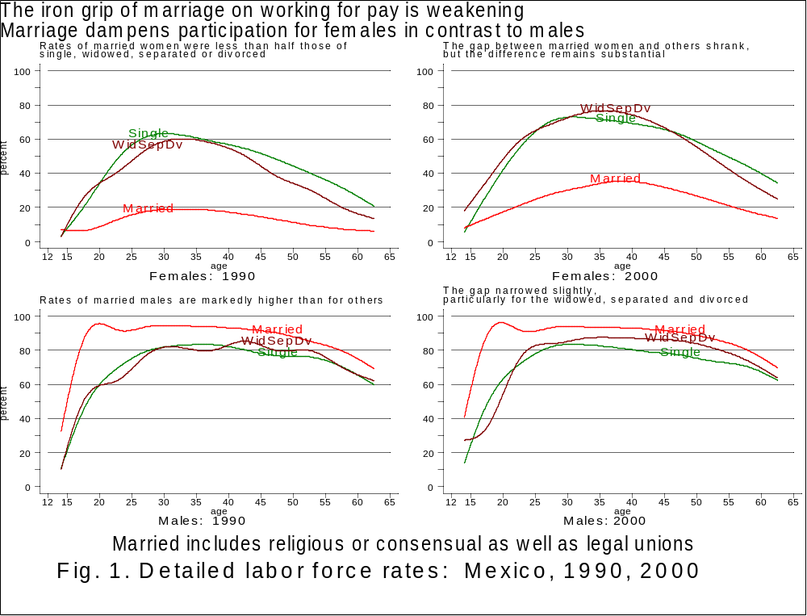

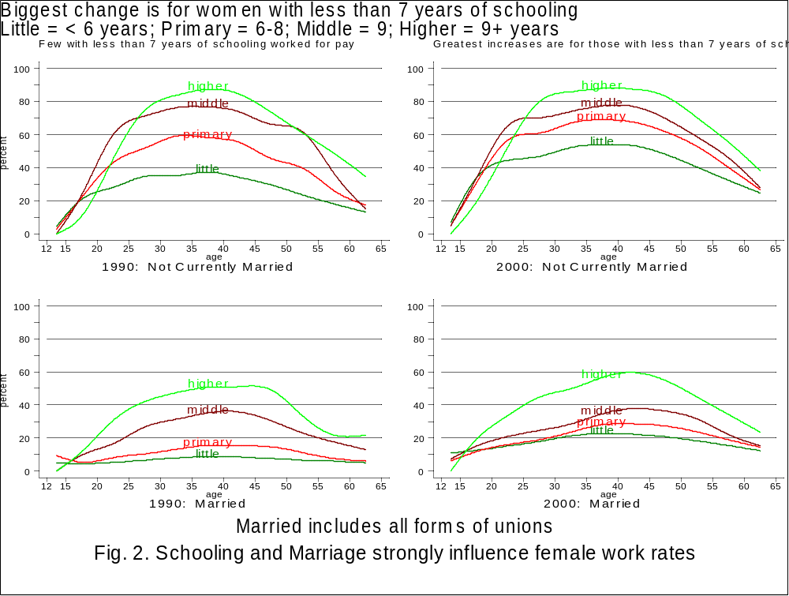
Figure 3. Female labor force participation rates by age
United States, 1880-1990 and Mexico, 1970 and 1990

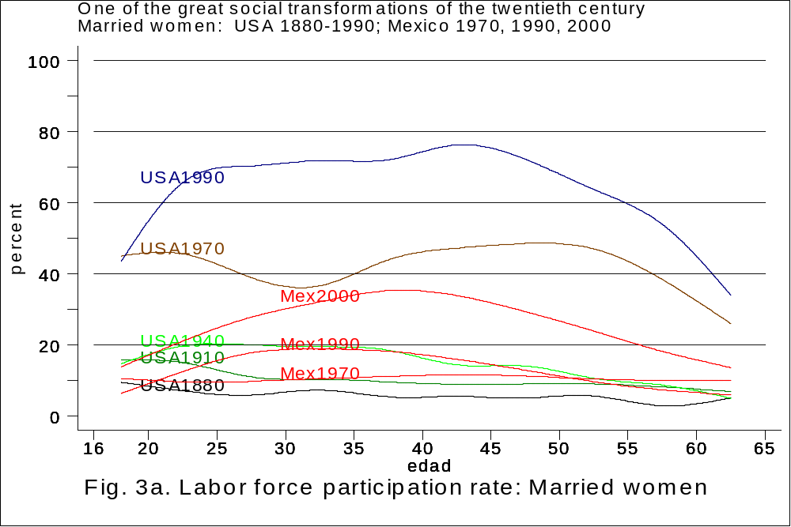

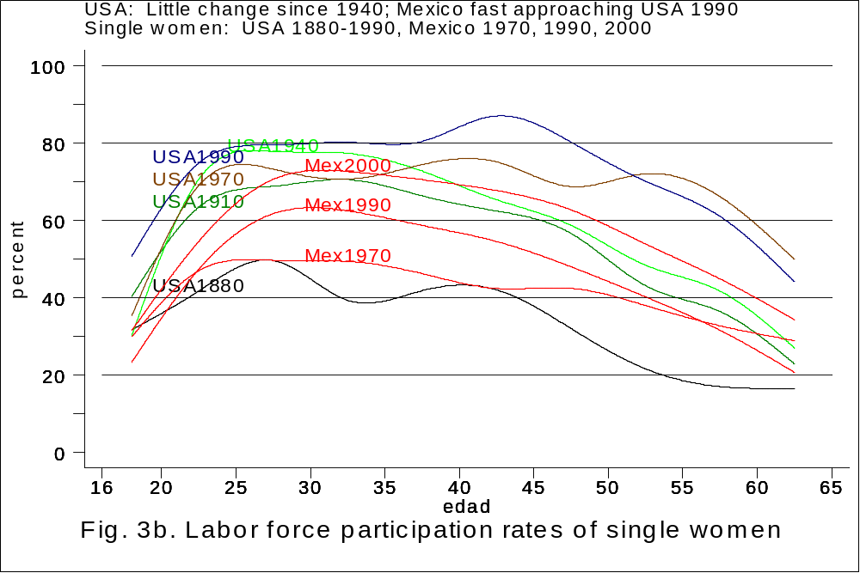

Research for this paper was funded by Grant SBR-9908380 from the National Science Foundation. We thank Matt Sobek for making available to us his historical census microdata series on women in the United States labor force.
The team is made up of: Cecilia Rabell Romero, Marta Mier y Terán, Virgilio Partida Bush, Marco Antonio Ramirez Mocarro, Rodolfo Corona, Dídimo Castillo, Marcela Eternod, Susan De Vos, and the authors of this paper.
Sobek (1997:58-113) offers an insightful, comprehensive analysis of the shortcomings of census enumerations of the United States on women in the labor force and how for more than a century census officials and scholars have proposed to overcome them.
In contrast, it has long been held that the difference "…es de tal magnitud, que difícilmente podría ser atribuida a la distinta naturaleza de las fuentes" (García 1992:23). This thinking persists in the literature (García Guzmán, Blanco Sánchez and Gómez Muñoz 1999:279), notwithstanding the analysis by Jusidman and Eternod (1995), and confirmed here, suggesting that two-thirds of the difference is readily explained by the restricted sampling frame of the urban employment survey, and only one-third to the nature of the instruments. Moreover in the 1990s due to the inclusion of thirty-one more cities, results from the employment surveys are not strictly comparable.

