 | EUROPEAN COMMISSION  EUROSTAT  Directorate E: Social statistics  Unit E-4: Population, social protection | 
DOC. DEM/CEN/E4/3/03-7.5 EN
OR.: EN
Working Party on Demographic Statistics
and Population and Housing Censuses
Meeting of 19 and 20 February 2003
BECH Building, Room AMPERE
Luxembourg
7.5 Integrating European Census Microdata:
a joint project of the ECE Population Activities Unit
and the University of Minnesota Population Center,
2004-2008
Robert McCaa, Minnesota Population Center
Nikolai Botev, Population Activities Unit, UN-ECE (Geneva)
Working document for Item 7.5 of the Agenda
Integrating European Census Microdata
a joint project of the ECE Population Activities Unit
and the Minnesota Population Center,
2004-2008

Working document for item 7.5 of the agenda

7.5 Integrating European census microdata

Presentation of a project by the ECE Population Activities Unit (PAU) and the University of Minnesota Population Center (MPC) to anonymise, integrate, and disseminate census microdata samples of European countries for academic research. The project aims not only to get a better coverage in terms of countries and censuses than the former project of the PAU for the 1990 census round, but to provide restricted access to both national and international researchers. Instead of broadcasting entire samples to researchers as was the case with the 1990 project, the new initiative, called IPUMS-Europe, offers a web-based “extraction system” which will allow reasearchers to obtain without charge custom tailored extracts of both microdata and metadata by country, census year, sample density, sub-population and variables. Jointly funded by scientific organizations of the ECE and the USA, the project will be a partnership between the PAU, MPC, National Statistical Agencies, National Social Science Data Centers and University Research Departments. If previous IPUMS projects may be seen as guides, marginal costs of all partners will be covered by external grant monies.

The 1990 census round project organized by the PAU
Since 1992, the Population Activities Unit (PAU) of the Economic Commission for Europe (ECE), in cooperation with the United Nations Population Fund (UNFPA) and the U.S. National Institute on Aging (NIA), has been coordinating a project that resulted in the creation of a collection of cross-nationally comparable census microdata samples. As of December 2002, this collection covered fifteen countries in Europe and North America. All samples currently in the collection are based on the 1990-round of national population and housing censuses.
Census microdata were obtained directly from the National Statistical Offices (NSOs) of the participating countries. The samples were drawn by the NSOs, or PAU from the complete census files, thus the universes they represent are all persons and housing units in the participating countries. Most of the meta data and documentation related to the samples was obtained directly from the NSOs. Some documentation was made available by the ECE’s Statistical Division, which had carried out an independent study of the national practices during the 1990 round of censuses.
The recommendations regarding the design and size of the samples prepared for the project envisaged: (1) drawing individual-based samples of about one million persons; (2) progressive oversampling with age in order to ensure sufficient presentation of various categories of older people; and (3) retaining information on all persons co-residing in the sampled individual's dwelling unit. Most countries have drawn their samples in accordance with these principles. Some countries (specifically Estonia, Finland, Latvia and Lithuania) adhered to earlier recommendations and sampled only the population over age 50 (the samples for Estonia, Latvia and Lithuania cover the entire population over age 50 with the same sample density, while Finland sampled it with progressive over-sampling). Several countries provided samples that had not been drawn specially for this project, and cover the entire population without over-sampling (Figure 7.5-A.1).
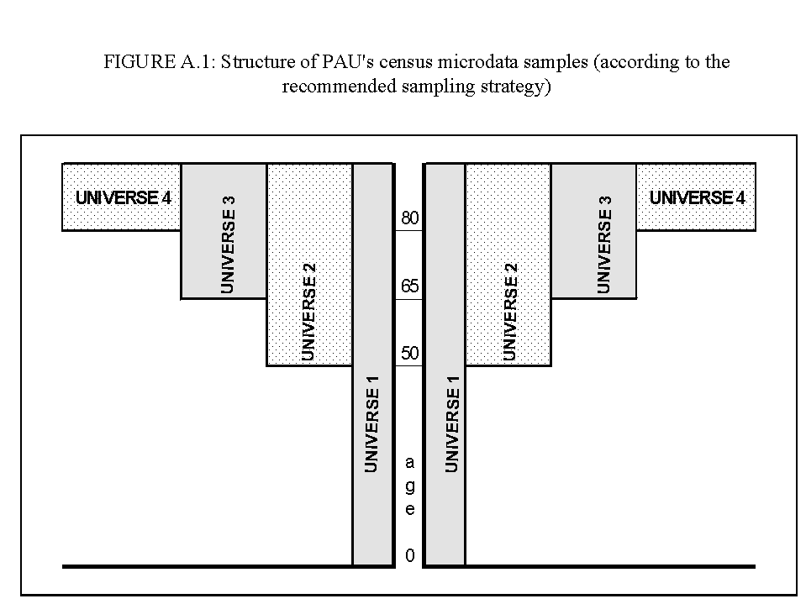
The processing of the data sets, which included drawing of the samples from the complete census files (when requested by the National Statistical Offices), cleaning (where necessary), and standardization/harmonization, was performed by the PAU and every effort was made to ensure quality and comparability.
The main medium for data distribution are CD-ROMs. The samples are prepared by the PAU as SAS transport data files. The Inter-University Consortium for Political and Social Research (ICPSR/NACDA) at the University of Michigan, as the collection’s main distributor, produces also an ASCII version of the data files, and includes separate files of SAS and SPSS data definition statements to describe the ASCII data file.
Beta and pre-release versions of seven data sets are available through ICPSR. Table 7.5-1 summarizes the status of data acquisition, processing, and access conditions for the participating countries.
Table 7.5-1: PAU Census Micro-Data Project Status of Data Acquisition and Processing for the Participating Countries (listed in order of receipt)
Bold = available from ICPSR
 |  | Sampling |  |  |  |  | Data Access Conditions
Countries | Design |  |  | Sample drawn by
USA |  |  | No |  | 1990 PUMS |  |  | general
Estonia |  |  | Partially |  | NSO |  |  | general
Finland |  |  | Partially |  | NSO |  |  | general
Romania |  |  | Yes |  | NSO |  |  | general
Switzerland |  |  | Yes |  | NSO |  |  | limited
Bulgaria |  |  | Yes |  | PAU |  |  | general
Hungary |  |  | Yes |  | NSO |  |  | limited
Czech Republic |  |  | Yes |  | PAU |  |  | general
Latvia |  |  | Partially |  | NSO |  |  | general
Turkey |  |  | No |  | 1990 SIS 5% sample |  |  | general
Lithuania |  |  | Partially |  | NSO |  |  | general
Russia |  |  | No |  | NSO |  |  | limited
Canada |  |  | No |  | 1991 PUMFs |  |  | limited
Italy |  |  | No |  | 1991 IStat 1% sample |  |  | limited
UK |  |  | No |  | 1991 SAR |  |  | limited

Beyond the 1990 project: the joint MPC-PAU initiative, IPUMS-Europe
While the 1990 round project fulfilled its objectives in terms of facilitating cross-national comparative research, and was judged a success by most parties involved, a number of problems arose. In the first place, the project was underfunded and the PAU lacked the computational infrastructure and human resources to sustain a pan-European project. Secondly, the UNECE lacks the necessary legal framework to archive and disseminate microdata. For the 1990s-round related work this was resolved through the signing of data-release agreements with each of the participating countries. Third, having only one census-round and the complex sampling design limited the research and policy-analysis value of the collection. Finally, various technical problems remain unresolved -- e.g. the distribution system of the 1990s was based on physical media (initially, QIC-tape cartridges, and more recently, compact discs), which proved cumbersome. The Internet is now the preferred solution because it offers enormous economies of scale and great savings of time, but if Internet distribution is to be done well, a substantial investment is required to develop and host the website, maintain the data and documentation on-line, and to provide necessary security.
The IPUMS-International project, under the direction of the University of Minnesota Population Center (MPC), offers means of addressing many of these issues. The MPC is a leader in the web-based dissemination of anonymized census microdata, including “restricted-access” microdata samples, such as those likely to be made available by European NSOs. Sustained for more than a decade by major infrastructural grants from the National Science Foundation and the National Institutes of Health as well as substantial on-going investments by the University of Minnesota, the MPC has developed a web-based microdata “extract” system which assists researchers to custom-tailor datasets by country, census year, sub-populations, variables, and sample density. More than one-hundred million person records are currently available to authorized researchers through the IPUMS-International and IPUMS-USA web-pages, with approximately ten million records scheduled to be added annually over the next five years.
A joint-project led by the PAU and the MPC proposes to capitalize on the experience and strengths of both entities to develop a European variant of the IPUMS-International system, similar to a Latin American initiative currently in progress. The IPUMS-Europe initiative aims not only to get a better coverage in terms of countries and censuses than the 1990 census round project of the PAU, but to provide improved—although restricted—access to both national and international researchers. Instead of distributing the entire samples to researchers on physical media, as with the PAU 1990 project (and indeed most microdata initiatives), the project will provide free of charge a web-based “extraction system” which will allow reasearchers to construct custom tailored extracts of both microdata and metadata by country, census year, sample density, sub-population and variables. Jointly funded by ECE and USA scientific organizations, the project will be a partnership between the PAU, MPC, National Statistical Agencies, National Social Science Data Centers and University Departments, such that marginal costs of all partners will be recovered by means of external grants. This model has proven highly successful for both the IPUMS-International and Latin America projects. Nonetheless, it is important to note that American granting officers have warned that European funding will be required to shoulder European costs, since Europe is, in the words of one grant officer “not a developing area”.

IPUMS-International means Integrated Restricted-Access, Anonymized Microdata Samples
The IPUMS-International carries “PUMS” embedded in its name, but in fact the data are available only as “Restricted-Access”, Anonymized Microdata Samples. Thus, “IRAAMS” would be the more literal acronym, and indeed when the IPUMS was internationalised in 1998, the Principal Investigators discussed replacing “PUMS” with a more suitable moniker. A decade-long unbroken string of successes in obtaining monetary resources from the National Science Foundation dissuaded us then, as it does now with the sister proposal IPUMS-Latin America, from adopting a more politically-correct name.
Nonetheless, it is important to understand that a comprehensive array of protections are in place--legal, administrative and technical--to guarantee the privacy and statistical confidentiality of census microdata samples incorporated into the database. While much of the published literature on statistical confidentiality ignores the legal and administrative environment, we remain firmly persuaded that the strongest system must take into account the three areas (Thorogood 1999).
First, with regard to legal mechanisms, IPUMS-International projects are initiated only in countries where a memorandum of understanding signed by the official statistical agency authorizes a project. No work is begun—indeed no funds are solicited—for a project without prior signed authorization from each NSO. Thus, the obstacle that hampered the successful completion of the PAU-Aging project (in which only about half the datasets were ultimately made available to researchers) is avoided from the very beginning. The IPUMS-International memorandum of understanding is entirely general in nature, yet it provides a legal framework for the project to proceed (Please see Appendix 7.5-A). Its ten clauses spell out: 1) rights of ownership, 2) rights of use, 3) conditions of access, 4) restrictions of use, 5) the protection of confidentiality, 6) security of data, 7) citation of publications, 8) the enforcement of violations, 9) sharing of integrated data, 10) and arbitration procedures for resolbing disagreements. There are no special or secret clauses. All members of the consortium are treated equally. The protocols have been revised and expanded as NSOs suggest modifications. Any new provisions are forwarded to current members of the consortium for their consideration and up-dating as necessary.
The Population Activities Unit and the Minnesota Population Center are obliged to share the integrated data and documentation with the national statistical agencies and to police compliance by users. The signed agreements are highly general and uniform across countries; details specific to each country such as fees and sample densities are negotiated separately with each national agency. Under a carefully worded legal arrangement, the Regents of the University of Minnesota are responsible for enforcing the terms of these accords. Any disputes with national statistical agencies will be settled by arbitration under the authority of the Chamber of Commerce of Paris.
Second, administrative measures limit access to the extract system to researchers, who:
- sign an electronic non-disclosure license;
- endorse prohibitions against a) attempting to identify individuals or the making of any claim to that effect and b) redistributing data to third parties;
- agree to use the data solely for non-commercial ends and to provide copies of publications to ensure compliance;
- place themselves under the authority of employers, institutional review boards, professional associations, or other enforcement agencies to deal with any alleged violation of the license;
- demonstrate a need to use some portion of the database, according to a project description which must be submitted with the electronic application for access;
- and, demonstrate sufficient research competence and infrastructural support required to use the data properly.
While the vetting of applications is performed by the Principal Investigators of the IPUMS-International project, an IPUMS-Europe advisory board made up of distinguished statisticians and researchers will be constituted to review on a regular basis all aspects of the project to ensure compliance with the memorandum of understanding. Table 7.5-2 lists projects approved for access by subject matter, university or research organization, funding agency, and human subjects protection boards, from May 2002 through January 2003. It is noteworthy that approximately one-half of applications are denied access because of a failure to adequately satisfy one or another of the specified conditions. It is gratifying to report that no user has yet appealed a denial of access.

Table7-5.2 Report on Approved Access to Restricted Microdata, IPUMS-International,
May 2002 – January 2003
Funding Agencies | Approved Projects (key words only)
Canadian Foundation for Innovation | Brain drain: sending and receiving countries
Council for the Development of Social Science Research in Africa | Calibration of birth registrations against census microdata for countries with strong border migrations.
Economic and Social Research Council, UK | Comparison of fertility patterns by migration status
National Science Foundation | Construction of life-tables for sub-national populations.
National Institutes of Health | Cross national studies of poverty and social issues
Norwegian University Development Aid Funding | Cross-national analysis of human health resources
Rockefeller Foundation | Cross-national analysis of wage structure/discrimination
Wellcome Trust | Cross-national comparison of the determinants of poverty
Over-sight Boards | Cross-national determinants of female labor force
CNIL: Commission Nationale Information et Liberte | Cross-national study of inequality
Comite National d'Ethique | Cross-national study of living standards and sanitation
Institutional Review Board (IRB) on research involving human subjects. Note: Any university or research organization funded by the National Institutes of Health must establish an IRB or equivalent. | Demographic and spatial dimensions of homicide rates in relation to demographic changes.
Inter-University Consortium for Political and Social Research | Demographic processes: fertility, mortality, migration
IRD scientific commission (Conseil Scientifique) | Demographic profiles of older populations
ISA and its research committees RC28 and RC33 | Develop regional accounts systems
National Committees for Research Ethics in Norway | Development of cross national social interaction and stratification scales.
USA Federal Code title 13/title 26 /title 5 | Disability and welfare expenditures
Vice-decanat a la recherche, Universite de Montreal, Documents pour l'ethique | Education stock estimates for evaluating the efficiency of health systems
Professional Associations | Educational gaps between minority and majority populations
American Economic Association | Effects of AIDS on school enrollments
American Public Health Association | Effects of economic growth on demand for skills and education and the returns to labor.
American Sociological Association | Effects of educational mismatches on wages and salaries
International Union for the Scientific Study of Population (IUSSP) | Effects of national poverty programs on child labor and school attendance
Latin American and Caribbean Studies Association | Effects of social networks on rural-ruban migration.
Population Association of America | Effects of urbanization on internal migration
Universities/Research Organizations | Emigration: the gender gap
Europe | Emission of green house gases: population and labor
Cardiff University | Evolution of non-agricultural employment in rural areas
Demographic Studies Center - University Auton. of Barcelona | Extent of death clustering by regions
Department of Statistics, University of Florence | Gender differences in educational attainment
INED Paris (France) | Gender earnings differences by ruralurban areas
Institut d etudes politiques de Paris | Household structures of the elderly
Institut francais de recherche en Afrique (IFRA) | Human welfare, agriculture and the environment
Ministry of Economic Development and Trade of Russian Federation | Inequality of wages: instruction of advanced graduate students on the use of census microdata
Novosibirsk State Technical University | Immigration of specific nationalities
University College London | Impact of climate variation on poverty
Canada | Infrastructure and economic activities on public health
Department of Demography, University of Montreal | Labor supply and regional development
Queen's University | Living arrangements of the elderly around the world
Simon Fraser University | Marriage transitions in developing countries
Statistics Canada -Library and information centre | Marriage, child labor, and polygamy
University of Toronto | Material inequality
USA | Migrants by country of origin/destination & duration
Boston University | Migration from Mexico to the USA
Brown University | Occupational changes and reshaping of industrial policies
Columbia University | Period-cohort analysis of educational attainment in comparative perspective
Dept. of Economics, Massachusetts Institute of Technology | Recalibration of survey data using census microdata
East-West Center | Regional clustering of infant and child mortality
Florida State University | Religion and nationalism
George Mason University | School and work in developing and developed countries.
Georgetown Public Policy Institute | Social determinants of marital fertility
Harvard University | Substitution of wooden housing materials and effects on forest and environment
Illinois Wesleyan University | Teach advanced graduate students how to use census microdata for the study of public health issues
International Program Center-U.S. Census Bureau | Teach advanced graduate students to use census microdata to analyze labor markets
Johns Hopkins Bloomberg School of Public Health | Teach advanced graduate students to use census microdata to study aging and household structures
Johns Hopkins Population Center | The marriage squeeze and marriage rates: comparisons
Marshall University | Transitions from adolesence to adulthood: education, work, marriage, child-rearing
Northwestern University | Transitions to adulthood: life course trajectories by gender and household characteristics.
Office of Population Research - Princeton University | Trends in educational attainment; impact of work force.
ORC Macro International | Well being of the elderly
Population Research Institute Penn State University | Why the brain drain is more severe in some countries.
Population Studies Center University of Michigan | Women in the labor market
San Diego State University | Other World Regions
Stanford University | African Population and Health Research Center
Tufts University | Centro de Investigacion y Docencia Economicas.
Tulane University School of Public Health | Hong Kong University of Science and Technology
United States Bureau of the Census | National University of Singapore
University at Albany, SUNY | The University of Nairobi
University of California Riverside | The World Bank
University of California, Berkeley | Universidad Externado de Colombia
University of Chicago | Universidad Pedagogica Experimental Libertador
University of Illinois at Chicago | World Agro-Forestry Centre
University of Maryland | World Health Organization
University of Minnesota
University of North Carolina School of Public Health
University of North Carolina at Chapel Hill
University of Pennsylvania
University of Pittsburgh
University of Southern California
University of the Pacific
University of Wisconsin--Demography and Ecology
Yale University
Third, are the technical measures taken to ensure statistical confidentiality. In cases where the NSO requests that the MPC apply anonymization procedures, we implement the following technical protections (based on Thorogood 1999):
- adopt sample size according to national norms or conventions;
- limit geographical detail to administrative units with 100,000+ population;
- top and bottom code unique categories;
- round, group, or band age as necessary;
- suppress date of birth (report age);
- suppress place of birth (<100,000 population);
- suppress place of residence, work, study, and migration (<100,000 population);
- systematically “swap” (recode) place of enumeration for a fraction of households;
- randomly order households within administrative units;
- and, conduct a sensitivity analysis once these are imposed to determine what additional measures may be required.
In practice, disclosure of confidential information is highly improbable. Indeed, over the past forty years of disseminating census microdata in the United States and elsewhere there is not a single allegation of misuse or breach of statistical confidentiality. The IPUMS-International procedures are designed to extend this perfect record.

IPUMS-Europe, more countries, more censuses, and more comparability.
With virtually unlimited server capacity provided by the University of Minnesota Population Center it will be possible to incorporate many more censuses than for the PAU-Aging project and many more countries as well. Given the cooperation of NSOs, samples from as many as 15-20 countries and for three, four or more census rounds per country may be incorporated into the database. While at present, only five countries have signed onto the project, if the NSOs that are inclined to participate actually sign agreements to join the initiative, the total number might rise to as many as fifteen or more (Table 7-5.3).

Table 7-5.3. Verified Extant Microdata by Census Year (bold) and Country
+ = participated in PAU 1990 census round microdata dissemination project
* = inclined to participate in IPUMS-Europe project
“signed” as of 17 Februrary 2003
Country | millions | pre-1960 | 1960s | 1970s | 1980s | 1990s | 2000s
Albania | 3.4 | 1950 & 55 | 1960 & 69 | 1979 | 1989 |  | 2001
*Austria | 8.1 | 1951 | 1961 | 1971 | 1981 | 1991 | 2001
Belarus | 10.0 |  |  |  | 1989 | 1999 | …
Belgium | 10.3 |  | 1961 | 1970 | 1981 | 1991 | 2001
Bosnia and Herzegovina | 3.4 |  |  |  |  | 1991 | 2001
*+Bulgaria | 8.1 | 1956 | 1965 | 1975 | 1985 | 1992 | 2001
Croatia | 4.7 |  |  |  |  | 1991 | 2001
*+Czech Republic (signed) | 10.3 | 1950 | 1961 | 1970 | 1980 | 1991 | 2001
Denmark | 5.4 | 1950 & 55 | 1960 & 65 | 1970 & 76 | 1981 | 1991 | 2001
+Estonia | 1.4 |  |  |  | 1989 |  | 2000
+Finland | 5.2 | 1950 | 1960 | 1970 & 75 | 1980 & 85 | 1995 & 90 | 2000
*France IPUMS-I (signed) | 59.2 |  | 1968 & 62 | 1975 | 1982 | 1990 | 1999
*Germany | 82.2 |  | 1961 | 1970 | 1987 | micro | micro
*Greece | 10.9 | 1951 | 1961 | 1971 | 1981 | 1991 | 2001
*+Hungary (signed) | 10.0 |  |  | 1970 | 1980 | 1990 | 2001
Iceland | 0.3 | 1950 | 1960 |  | 1980 |  | 2001
*Ireland | 3.8 | 1956 | 1961 & 66 | 1971 & 76 | 1981 & 86 | 1996 &91 | 2002
*+Israel | 6.4 |  | 1967 & 61 | 1972 | 1983 | 1995 | …
*+Italy | 57.8 |  | 1961 | 1971 | 1981 | 1991 | 2001
+Latvia | 2.4 |  |  |  | 1989 |  | 2000
Liechtenstein | 0.0 | 1950 | 1960 | 1970 | 1980 | 1990 | ...
+Lithuania | 3.7 |  |  |  | 1989 |  | 2001
Luxembourg | 0.4 |  | 1960 & 66 | 1970 | 1981 | 1991 | 2001
FYR Macedonia | 2.0 |  |  |  |  | 1994 & 91 | 2001
Malta | 0.4 | 1957 | 1967 |  | 1985 | 1995
*Moldova, Republic | 4.3 |  |  |  | 1989 |  | 2002
Netherlands | 16.0 |  | 1960 | 1971 |  | 1991 | 2003
Norway | 4.5 | 1801 - 1950 | 1960 | 1970 | 1980 | 1990 | 2001
Poland | 38.6 | 1950 | 1960 | 1970 & 78 | 1988 |  | 2002
*Portugal | 10.0 | 1950 | 1960 | 1970 | 1981 | 1991 | 2001
+Romania | 22.4 | 1956 | 1965 | 1977 |  | 1992 | 2002
+Russia | 144.4 | 1959 | 1970 | 1979 | 1989 | 1994 | 2002
San Marino | 0.0 |  |  | 1976
Slovakia | 5.4 |  |  |  |  | 1991 | 2001
*Slovenia (signed) | 2.0 |  |  |  | 1981 | 1991 | 2002
*Spain (signed) | 39.8 |  | 1960 | 1970 | 1981 | 1991 | 2001
+Sweden | 8.9 | 1950 | 1960 & 65 | 1970 & 75 | 1980 & 85 | 1990 | ...
*+Switzerland | 7.2 | 1950 | 1960 | 1970 | 1980 | 1990 | 2000
+Turkey | 66.3 |  | 1960 | 1970 & 75 | 1980 & 85 | 1990 | micro
Ukraine | 49.1 |  |  |  | 1989 |  | 2001
+United Kingdom | 60.0 | 1851, 1881 | 1961 | 1971 | 1981 | 1991 | 2001
Yugoslavia | 10.7 | 1953 | 1961 | 1971 | 1981 | 1991 | 2001
Total extant microdatasets |  | 18 | 8 | 13 | 29 | 25 | 33
Note: please email any corrections, additions or updates to: rmccaa@umn.edu
The project proposes to incorporate not only samples from the 1990 and 2000 census rounds, but also from the 1980s and earlier to the extent that the data are available or may be recoverable. We propose a uniform sample design of every n^{th} dwelling for private households, after a random start (for institutional households, every n^{th} person). For a geographically ordered database, this strategy will enhance the power of the sample. The sampling fraction will vary from country to country, and perhaps even census-to-census, according to national regulations and conventions. In the case of Latin America a sampling fraction of 10% has become something of a de facto standard. Given the restricted access of the IPUMS databases it is hoped that for European countries with PUMS their samples may be augmented to include the household as the sampling unit and to provide higher densities as well.
The data dissemination agreements and license fees provide not only for dissemination rights, but also for the supply of ancillary materials (such as codebooks and technical publications) and technical support by the staff of these agencies. As needed, this pool of knowledgeable specialists will be supplemented with other experts drawn from across the continent. They will answer questions on census enumeration procedures and post-enumeration data processing, the methodology employed to create existing samples, and specific integration problems (such as the details of economic, education, housing, and geographic variables for particular countries).
The goal of this project is not simply to make European census data available; it will also make them usable. Even where census microdata can be obtained, comparison across countries or time periods is challenging because of inconsistencies between datasets and inadequate documentation of comparability problems. Because of this, comparative international research based on pooled census samples is rarely attempted. This project will reduce the barriers to comparative research within Europe and beyond by converting census microdata into a uniform format, providing comprehensive documentation, and by making the data freely available to researchers through a web-based access system.
Thanks to PAU and the United Nations Statistics Division, a nearly complete collection of census documentation, including enumeration forms, enumerator instructions, and codebooks has been assembled for almost every country in Europe. The PAU documentation collection is catalogued by country, census year, and item. For each census, there are dozens of items, including all versions of census enumeration forms; manuals for enumerators, data editing instructions; codebooks; sampling descriptions; and post-enumeration surveys. Microdata will be supplied by the national statistical agencies once funding is obtained and the project gets underway.
Table 7-5.4 illustrates the current topics by country and census year covered in the IPUMS-International system as of December 2002. Dwelling and household variables are omitted from this table. A second release scheduled for 2003 will significantly increase the menu of available variables. The number of integrated variables will be expanded even farther for the IPUMS-Europe project, ultimately to include all variables that appear in at least three or more countries.
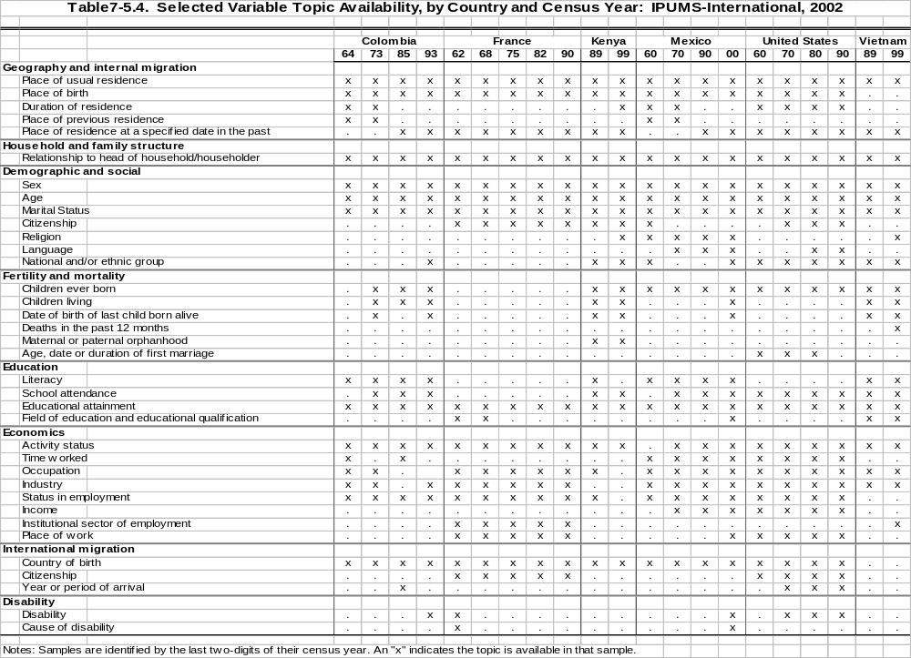
United Nations organizations have twice sponsored large-scale projects for regional harmonization of census microdata. The first was the OMUECE project sponsored in the 1960s and 1970s by CELADE (Latin American Center for Demography). Under this project, CELADE created standardized versions of twenty-nine Latin American censuses taken between 1960 and 1976. The second project was undertaken by the United Nations Population Activities Unit (PAU) in Geneva. This project, which provides the starting point for the current effort, is a standardization of microdata from the 1990 round of censuses of seventeen European and North American countries. These two initiatives have provided IPUMS-International with valuable information. They have made it possible to take advantage of the investments already made by the United Nations and to learn from the experience of earlier attempts at international census harmonization.
The two UN projects had very different design philosophies, and neither one is ideal. The OMUECE project included only the lowest common denominator of variables available across all countries. This meant that about half the variables available in the original censuses were discarded altogether, and much critical detail on such variables as occupation and ethnicity was eliminated from the harmonized version of the datasets. The loss of detail so severely compromised the database that most users opted to work instead from the original incompatible samples. The PAU project represents the opposite extreme: there has been no attempt to standardize coding schemes for complex categorical variables such as religion, family relationship, occupation, ethnicity, or language. Only the simplest variables such as age, sex, marital status, and employment status are recoded into a common scheme. The PAU data transformations make international comparisons easier, but they are a half measure.
The IPUMS-International design strategy is more ambitious than that of either CELADE or PAU. Unlike CELADE, the new project retains all the detail provided in the original samples. Unlike PAU, the new project provides a truly integrated database, in which identical categories in different census samples always receive identical codes. Several strategies are employed to achieve these competing goals. In some cases, the original variables are compatible and recoding them into a common classification is straightforward. In this situation, the documentation notes any subtle distinctions between censuses. For most variables, however, it is impossible to construct a single uniform classification without losing information. Some samples provide far more detail than others, so the lowest common denominator of all samples inevitably loses important information. In these cases, composite coding schemes are constructed. The first one or two digits of the code provide information available across all samples. The next one or two digits provide additional information available in a broad subset of samples. Finally, trailing digits provide detail only rarely available. Future versions of the data access system will guide researchers to the level of detail appropriate for the particular cross-national or cross-temporal comparisons they are making.
The IPUMS-Europe project will adopt uniform coding schemes, nomenclatures and classifications, based where possible on the Recommendations for the 2000 Censuses of Population and Housing in the ECE Region (Statistical Standards and Studies No. 49), and such international standards as:
- United Nations Statistics Division (1998) Principles and Recommendations for Population and Housing Censuses.
- unesco (1997) The International Standard Classification of Education (isced 1997).
- International Labor Office (1990) International Standard Classification of Occupations (isco-88).
- United Nations Statistics Division (1990) International Standard Industrial Classification of All Economic Activities (isic-88).
In addition to converting the European censuses into IPUMS-International format, a variety of new variable classifications will be created specifically for the IPUMS-Europe project. In some cases, incompatibilities across continents are so great that the composite coding scheme is significantly more cumbersome than the original variable coding design. The European classifications will take advantage of commonality in social structure and similarity in census questionnaires across the region to create more streamlined classifications.
To take the simplest example, the classification scheme for marital status illustrates this point. Under the IPUMS-International design, the first digit of marital status has four categories: single, married/in union, separated/divorced/spouse absent, and widowed. This is the maximum number of categories consistently distinguishable across all samples in the database. The distinction between divorced and separated is not maintained in all samples, so these categories are combined in the fully comparable first digit of marital status. At the second digit, divorced and separated persons can be distinguished, as can formal marriages from consensual unions. The third and final digit differentiates among types of marriages (civil, religious, polygamous), information only available for select countries.
Table 7-5.5 illustrates, for the variable “employment status”, how the original codes in the NSO provided census microdata are translated into a composite integrated coding scheme. The babel of concepts and coding schemes in this table hints at the complexities involved in developing a comprehensive system for a single variable. As more experience is gained by incorporating more countries and censuses, the table will surely be modified, but the basic structure of the composite coding scheme will remain. Thanks to the advice of experienced national consultants it is possible to readily identify problematic concepts and revise the harmonized codes accordingly. It is important to understand that no decisions are taken at the central integration center without comprehensive input by national experts who work as consultants to the project. This decentralized approach allows multiple projects to proceed simultaneously without fear of duplication or wasted effort.

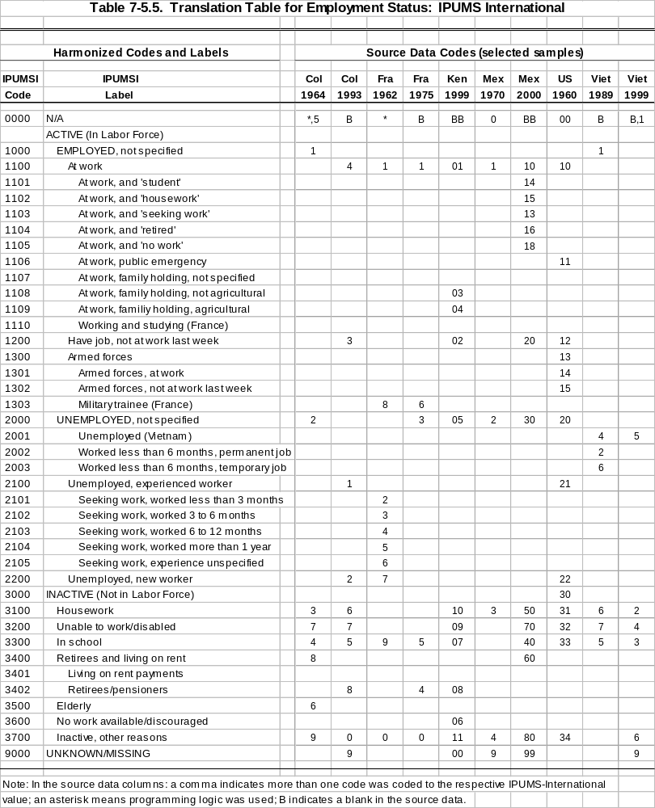
Geographic variables pose the greatest challenges. Within the cost constraints of the present project, full harmonization of the lowest level of geographic information available, even taking into account constraints imposed by statistical confidentiality measures, cannot be attempted. However an attempt will be made to create a consistent definition of large metropolitan districts. Moreover, wherever feasible, maps will be provided of administrative districts identified in the microdata and any other ancillary geographic information available.
In addition to recoding variables to maximize comparability, additional processing will be done to enhance usability. Some procedures are straightforward, such as the addition of compatible variables on serial number, census year, country code, size of unit, and case weights. Others are more complicated; some examples follow.
European census authorities have long collected data on households and relationships of individuals within households. With a few exceptions, family interrelationships are preserved in the microdata. Individual-level variables describing interrelationships among family members will be constructed so that researchers can create specialized measures tailored to specific research topics, such as living arrangements of the aged or of single parents. Three pointer variables will give the location within the household of each individual’s mother, father, and spouse (or consensual partner). These pointer variables are among the greatest contributions we can make to the datasets. They allow users to easily attach characteristics of these kin to the records of individuals. Sophisticated users find them to be convenient tools for the construction of specialized own-child fertility measures and measures of marriage characteristics, including consensual unions, where the census collects this information.
The European censuses rarely provide for more than ten kinds of family relationships, and the information available for sorting out ambiguous relationships varies slightly across censuses. For the sake of consistency, many investigators will want to use family interrelationship variables based entirely on information available in all samples. There are certain applications, however, for which the greater precision available in some samples is required. Following the guidelines originally developed by the IPUMS-USA project, data-flags will be used to accommodate these needs. The pointer variables will be accompanied by flags indicating: (1) if the link would be the same even if minimal information were used; (2) if the link was only made because of extra information available in the particular census; or (3) if the link is contradicted by extra information available in that census.
A variety of fully compatible variables will be constructed to describe family and household characteristics at the individual and household level. Some of these indicators—such as family membership, family size, number of own children, number of own children under five years old, and age of eldest and youngest own child—are already incorporated in IPUMS-International. For the IPUMS-Europe database, new constructed variables will be designed to describe household and family composition in ways that reflect the diversity of family forms across Europe.

IPUMS-Europe: What is needed soon, if a funding proposal is to be submitted this year…and the project is to be completed by 2009.
Three elements are needed if funding is to be obtained soon:
- signed agreements from roughly fifteen countries;
- rough budget of the marginal costs for drawing samples and anonymizing the microdata, where these tasks will be performed by the NSOs (we have suggested a cost of US$2,500 per sample—if your costs are likely to be greater than this figure, please communicate that information to us without delay);
- year in which the 2000-round census microdata are likely to become available so that a rough calendar of work may be submitted with the proposal.
A first-draft of what we think is a competitive proposal is at hand (see the documented circulated on CD to most European NSOs last August), but if it is to be submitted to a funding agency this year, signed agreements are needed from a solid core of, say 15, national statistical agencies. The National Institutes of Health, for example, has already made it clear that emails, converstations at conferences, friendly telephone chats and other encouraging signs and signals cannot substitute for formal endorsement of the project.
Second, regarding a rough budget for drawing samples and anonymizing the microdata, we have suggested a figure of US$2,500 per sample. Every NSO that signs an agreement will be budgeted at that figure, unless a signed request is received for additional funding. To avoid that figure being reduced, it will be helpful to have a couple of lines of texts justifying the additional costs.
Third, while the project will work with a very flexible calendar, it will be helpful to have an indication regarding the likely year in which the 2000 round census microdata are projected to become available. The integration work for each country will be scheduled for that year or the year afterward.
Fortunately, most NSOs have already supplied the needed original source documentation, either to the PAU or the MPC, necessary to detail the variables likely to be available for the various countries and censuses.
With your cooperation and the assistance of statisticians and social scientists in the participating nations a valuable new resource for comparative research is coming into being. We welcome the opportunity to work with you on this pan-European project.
Appendix 7-5.A1 Memorandum of Agreement.
Letter of Understanding
Integrated Public Use Microdata Series International
and [National Statistical Agency of X]
Purpose. The purpose of this letter is to specify the terms and conditions under which metadata and microdata produced by the [National Statistical Agency of X] shall be distributed by Integrated Public Use Microdata Series International of the University of Minnesota.
- Ownership. The [National Statistical Agency of X] is the owner and licensee of the intellectual property rights (including copyright) in the metadata and microdata of [X] acquired by the University of Minnesota to be distributed by Integrated Public Use Microdata Series International. This agreement explicitly authorizes release to the University of census microdata of [X] that may be in the possession of third parties. The University is obligated to provide to the [National Statistical Agency of X] timely notice of any such acquisitions and, upon request and without cost, provide copies of same.
- Use. These data are for the exclusive purposes of teaching, scientific research and publishing, and may not be used for any other purposes without the explicit written approval, in advance, of the [National Statistical Agency of X].
- Authorization. To access or obtain copies of integrated microdata of [X] from Integrated Public Use Microdata Series International, a prospective user must first submit an electronic authorization form identifying the user (i.e., principal investigator) by name, electronic address, and institution. The principal investigator must state the purpose of the proposed project and agree to abide by the regulations contained herein. Once a project is approved, a password will be issued and data may be acquired from servers or other electronic dissemination media maintained by Integrated Public Use Microdata Series International, the [National Statistical Agency of X], or other authorized distributors. Once approved, the user is licensed to acquire integrated metadata and microdata of [X] from Integrated Public Use Microdata Series International or other authorized distributors. No titles or other rights are conveyed to the user.
- Restriction. Users are prohibited from using data acquired from the Integrated Public Use Microdata Series International or other authorized distributors in the pursuit of any commercial or income-generating venture either privately, or otherwise.
- Confidentiality. Users will maintain the absolute confidentiality of persons and households. Any attempt to ascertain the identity of a person, family, household, dwelling, organization, business or other entity from the microdata is strictly prohibited. Alleging that a person or any other entity has been identified in these data is also prohibited.
- Security. Users will implement security measures to prevent unauthorized access to microdata acquired from Integrated Public Use Microdata Series International or its partners.
- Publication. The publishing of data and analysis resulting from research using metadata or microdata of [X] is permitted in communications such as scholarly papers, journals and the like. The authors of these communications are required to cite [National Statistical Agency of X] and Integrated Public Use Microdata Series International as the sources of the data of [X], and to indicate that the results and views expressed are those of the author/user.
- Violations. Violation of the user license may lead to professional censure, loss of employment, and/or civil prosecution. The University of Minnesota, national and international scientific organizations, and the [National Statistical Agency of X] will assist in the enforcement of provisions of this accord.
- Sharing. Integrated Public Use Microdata Series International will provide electronic copies to the [National Statistical Agency of X] of documentation and data related to its integrated microdata as well as timely reports of authorized users.
- Jurisdiction. Disagreements which may arise shall be settled by means of conciliation, transaction and friendly composition. Should a settlement by these means prove impossible, a Tribunal of Settlement shall be convened which will rule upon the matter under law. This Tribunal shall be composed of an (1) arbitrator, which shall be elected by lot from the list of Arbitrators of the Chamber of Commerce of Paris. This agreement shall be governed by, and construed in accordance with, generally accepted principles of International Law.

Date: ________________________________________
Signed: ________________________________________
Regents of the University of Minnesota
By: Kevin J. McKoskey, Sponsored Projects Administration
Date: ________________________________________
Signed: ________________________________________
Rev. Dec. 5, 2002

Robert McCaa is Professor of Population History, University of Minnesota, and, since 1998, Principal Investigator and International Projects Coordinator of the Minnesota Population Center’s IPUMS-International projects. The IPUMS-Europe project proposal may be inspected at: http://www.hist.umn.edu/~rmccaa/ipums-europe The IPUMS-International site is at: www.ipums.org/international Nikolai Botev is the Project Manager for the Population Activities Unit (PAU) of the United Nation’s Economic Commission Europe; the PAU web site is at: http://www.unece.org/ead/pau/p_home1.htm.

