ROMANIA  POPULATION  AND HOUSING  CENSUS  2002 |  |  |  |  |  |  |  |  |  |  |  |  |  |  |  | 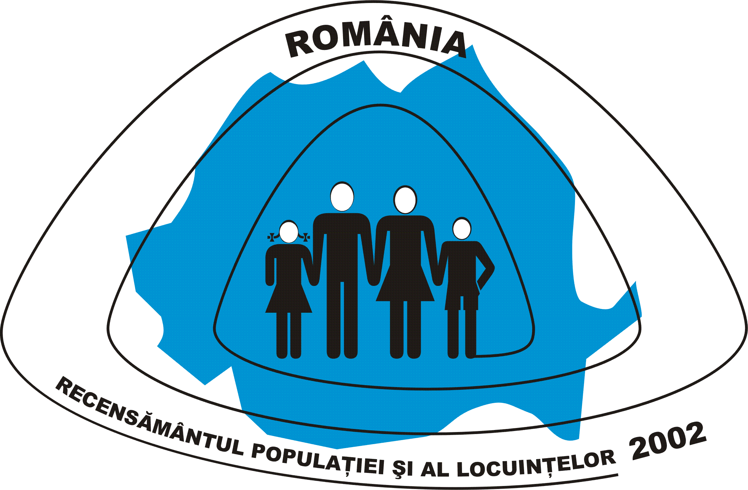
PC FORM
PERSONS LIVING IN COLLECTIVE UNITS - HOSTEL TYPE
The name of the collective living unit …………………………….………………..
The county ………………………….…………...……..  Municipality/town/commune ………………………...……  The component locality/village ……………………......…  Street…………………………………...……No. …...… |  |  |  |  |  |  |  |  |  | THE NUMBER OF THE FILE
The order number of collective living unit
within the file
 |  |  |  |  |  |  |  |  |  | The PC form’s number within the file
CHAPTER I : DATA REGARDING THE COLLECTIVE LIVING UNIT HOSTEL TYPE
1. THE TYPE OF COLLLECTIVE LIVING UNIT |  |  |  |  |  |  |  |  |  | 4. THE OWNRRSHIP FORM OF THE BUILDING
- school boarding, student’s hostel, school hostel ---  - worker’s hostel and dormitories,  hostel for non-family persons -------------------------  - children protection institutions * ----------------------  - old people’s hostels ---------------------------------  - hospital hostel, preventorium (medical treatment)  school, sanatorium for incurable diseases (mental  illness)--------------- ------------------------------ |  |  |  |  |  |  |  | ٱ 1  ٱ 2  ٱ 3  ٱ 4  ٱ 5 |  | Private ----------------------------------  State (public) -----------------------------------------  Private group (cooperative/association) -----------  Religious cults ---------------------------------- |  |  |  |  |  |  |  |  |  |  |  | ٱ 1  ٱ 2  ٱ 3  ٱ 4
 |  |  |  |  |  |  |  | ٱ 1  ٱ 2  ٱ 3  ٱ 4  ٱ 5 |  | 5. NUMBER OF THE ROOMS  (hostel rooms, collective dormitories,etc.) -└─┴─┴─┘
2. THE PLACEMENT OF THE COLLECTIVE LIVING UNIT
- in the building designated for the collective living unit  - in the housing building or with another destination  - provisional construction (improvised) and mobile units (barracks, wagon, etc.) ------------------ |  |  |  |  |  |  |  | ٱ 1  ٱ 2  ٱ 3 |  | 6. SPACE CAPACITY – NUMBER OF  PLACES ------------------------------ └─┴─┴─┴─┘
 |  |  |  |  |  |  |  | ٱ 1  ٱ 2  ٱ 3 |  | The PL form number of the first dwelling of the building (when is the case of the of the collective living units existing in several buildings, with dwellings - on the cassettes here enclosed - will be written the PL form number of the first dwelling or each building ) |  |  |  |  |  |  |  |  |  | └─┴─┴─┘  └─┴─┴─┘  └─┴─┴─┘  └─┴─┴─┘  └─┴─┴─┘
3. THE NUMBER OF THE BUILDINGS OF THE
COLLECTIVE LIVING UNIT IN THE FRAMEWORK OF
THE BUILDINGS GROUP
- total ----------------------------------------------- └─┴─┘
- out of which :
with dwellings ------------------------------- └─┴─┘
* institutions for children protection (including alternative families taking care of homeless children and those having severe handicap ), centers taking care of the children on emergency situation, maternity centers, therapeutically integration of children and young people, centers for therapeutically recovery and rehabilitation by working, school boarding – kindergartens, vocational schools, high schools, and special school centers - sanitation /hospital units = The PCS form will be completed, also.

When in the collective living units there are foreign citizens, who arrived after the March 18, 2001, then a PS form have to be completed.

RECAPITULATION OF THE ENUMERATED PERSONS IN THE FORM

The total number of the persons  (recorded on chapter II of the form) |  |  | Out of which :  Persons who arrived for a longer period of time  (recorded on the chapter II, item 1 code 2) |  |  |  |  | From the columns 1 and 2  The persons temporarily absent, who left for another place |  |  |  |  |  | Foreign citizens who arrived before March 18, 2001  ( recorded on chapter II, item 12.1, using a different code than 10)
 |  |  |  |  |  |  |  | To another place of the country  (item 2 code 2) |  |  | Abroad  (item 2 code 3)
M | F |  | M |  |  |  | F | M | F |  | M | F |  | M |  |  |  |  | F
1 | 2 |  | 3 |  |  |  | 4 | 5 | 6 |  | 7 | 8 |  | 9 |  |  |  |  | 10
 |  |  |  |  | Completed by, |  |  |  |  |  |  | Verified by,
Date, March ….. 2002 |  |  |  |  |  | The Name and the first name of the enumerator  ----------------------------------------- |  |  |  |  |  |  | The name and the first name of the chief enumerator  -----------------------------------------
 |  |  |  |  |  | The signature |  |  |  |  |  | The signature
 |  |  |  |  |  | ----------------------------------------- |  |  |  |  |  | -----------------------------------------

PERSON 1 CHAPTER II : DATA REGARDING THE RECORDED PERSONS ON THE COLLECTIVE LIVING UNIT –

HOSTEL TYPE

NAME AND THE FIRST NAME  (Will be written the father’s initial letter)  ------------------------------------------  ------------------------------------------ |  |  |  | 12. CITIZENSHIP  12.1 Romanian -----------------  Other citizenship --------------- | ٱ 10  └─┴─┘ |  |  | 20. STATUS OF EMPLOYMENT  Employee (engaged) -----------------  Employer, private enterprise owner --  Own account worker ---------------  Member of an agricultural company /  cooperative ------------------  Contributing family worker to the own  household --  Other situation ---------------------- |  | ٱ 1  ٱ 2  ٱ 3  ٱ 4  ٱ 5  ٱ 6
1. THE SITUATION AT THE REGISTRATION PLACE  The person from the collective living unit, left for good the household of the legal residence’s place mentioned on the identification card :  YES ٱ 1 NO ٱ 2 |  |  |  | 12.2 Whether the person has the second  citizenship, this is _{----------- └─┴─┘} |  |  |  |  |  | ٱ 1  ٱ 2  ٱ 3  ٱ 4  ٱ 5  ٱ 6
 |  |  |  | 13. ETHNICITY  Romanian -----------------------  Other ethnicity ------------------- | ٱ 10  └─┴─┘ |  |  |  |  | ٱ 1  ٱ 2  ٱ 3  ٱ 4  ٱ 5  ٱ 6
21. PLACE OF WORK
21.1 The full name of the unit (company, autonomous enterprise, institution, organization , etc.) of the sub – unit (section, workshop, factory,, store) where the person is working ---------------
------------------------------------
21.2 The main activity of the working place -
-----------------------------└─┴─┘
21.3 The location of theworking place :
Urban Rural
area area
2. THE SITUATION AT THE CENSUS MOMENT
At the “0” hours, of March 18, 2002, the
 |  |  |  | 14. MOTHER TONGUE  Romanian ------------------------  Other mother tongue ------------- | ٱ 10  └─┴─┘
person was :  Present ---------------------------  Temporarily absent, left to :  - another place from the country ---  - abroad -------------------- |  | ٱ 1  ٱ 2  ٱ 3
 |  | ٱ 1  ٱ 2  ٱ 3 |  | 15. RELIGION  Orthodox ------------------------  Other religion (confession) --------- | ٱ 10  └─┴─┘
3. THE LEGAL RESIDENCE (recorded on the identification card)
- In the place where the person is
enumerated ---------------------- ٱ 9
- In another place of the county ------------
---------------------------------------
Municipality/town/ commune --------------
-----------------└─┴─┴─┴─┴─┴─┘
16. EDUCATIONAL ATTAINMENT
16.1 The name and type (field of study) of the
highest level graduated school (for
persons born before September 15, 1991)₋₋₋
------------------------------------
--------------------------- └─┴─┘
16.2 Type of ownership of graduated
educational institution
- Public (state ownership) ----- ٱ 1
- Private ownership ---------- ٱ 2

16.3 The name and type of attending school –
field of study for persons born before
September 15, 1995 ₋₋₋₋₋₋₋₋₋₋₋₋₋₋₋
------------------------------------
--------------------------- └─┴─┘
16.4 Type of ownership of educational
institution attended by the person
- Public ---------------- ٱ 1
- Private ------------- ٱ 2

 |  |  |  |  |  |  |  | - in the same place --------  - other place the same county  - other county ------------  - other country ------------- | ٱ 1  ٱ 2 ٱ 3  ٱ 4 ٱ 5  ٱ 6

22. OWNERSHIP STRUCTURE OF PLACE

OF WORK , OF ENUMERATED PERSON
- Abroad ---------------------└─┴─┘
 |  |  |  |  |  |  |  | State -----------------------------  Private ------------------------------  Mixed structure ----------------------  Own household -------------------  Other household than own household |  | ٱ 1  ٱ 2  ٱ 3  ٱ 4  ٱ 5
4. THE PREVIOUS LEGAL RESIDENCE  (whether had the legal residence in another locality)  - In the county --------------------└─┴─┘ |  |  |  |  |  |  |  |  |  | ٱ 1  ٱ 2  ٱ 3  ٱ 4  ٱ 5
Municipalities / towns -------- ٱ 1  communes------------------ ٱ 2  - In another country ---------------└─┴─┘ |  |  |  |  |  |  |  | 23. DURATION OF UNEMPLOYMENT (only for persons who at the item 17 stated that are unemployed – codes 2 or 3).
 |  |  |  |  |  |  |  | 23.1 Duration  - less than 6 months -------------  - between 6 – 9 months ---------  - between 9-27 months --------  - 27 months and over -----------  23.2 The benefits of persons :  - Unemployment aid / benefits ---  - Benefits related to professional integration ---  - Support allowances ------------  Not receiving any benefits --- |  | ٱ 1  ٱ 2  ٱ 3  ٱ 4  ٱ 5  ٱ 6  ٱ 7  ٱ 8
5. THE YEAR OF ESTABLISHMENT OF THE  ACTUAL LEGAL RESIDENCE  └─┴─┴─┴─┘ |  |  |  |  |  |  |  |  |  | ٱ 1  ٱ 2  ٱ 3  ٱ 4  ٱ 5  ٱ 6  ٱ 7  ٱ 8
6. THE BIRTH PLACE |  |  |  |  |  |  |  |  |  | ٱ 1  ٱ 2  ٱ 3  ٱ 4  ٱ 5  ٱ 6  ٱ 7  ٱ 8
- In the locality of the enumeration ٱ 90  - In another place of the county ₋₋₋₋₋₋₋₋₋₋₋  ----------------------------- └─┴─┘  Municipalities/touns ----------- ٱ 1  Communes ------------------ ٱ 2 |  |  |  |  |  |  |  |  |  | ٱ 1  ٱ 2  ٱ 3  ٱ 4  ٱ 5  ٱ 6  ٱ 7  ٱ 8
 |  |  |  | 17. THE ECONOMIC STATUS OF THE  ENUMERATED PERSON AT THE  CENSUS MOMENT  (the week of March 11 – 17,2002) |  |  |  | 24. USUAL ECONOMIC SITUATION DURING THE PRECEDING YEAR OF THE CEMNSUS (March 2001 – March 2002)  24.1 During the major part of the year the enumerated person had the same economic status as it was at the census moment ?  YES ٱ 1 NO ٱ 2  24.2 Whether NO, what was
- In another country -------------- └─┴─┘ |  |  |  | Employed ---------------------------  Unemployed:  - seeking another place of work ----  - first-time job-seeker ----  Pupil / student ------------------------  Pensioner ---------------------------  Homemaker --------------------------  Dependent of a supporter ------------  Dependent on a public aid or private  organization support --  Other situation (incomes from rents, interests, leasing , other sources ) ----- |  | ٱ 1  ٱ 2  ٱ 3  ٱ 4  ٱ 5  ٱ 6  ٱ 7  ٱ 8  ٱ 9
7. THE SEX Male ٱ 1 Female ٱ 2 |  |  |  |  |  | ٱ 1  ٱ 2  ٱ 3  ٱ 4  ٱ 5  ٱ 6  ٱ 7  ٱ 8  ٱ 9
8. DATE OF BIRTH  Year└─┴─┴─┴─┘ Month└─┴─┘ Day└─┴─┘ |  |  |  |  |  | ٱ 1  ٱ 2  ٱ 3  ٱ 4  ٱ 5  ٱ 6  ٱ 7  ٱ 8  ٱ 9 |  | that usual economic status :  Employed ----------------------------  Unemployed :  - seeking another working place ----  - first-time job-seeker ----  Pupil / student ------------------------  Pensioner ----------------------------  Homemaker --------------------------  Dependent of a supporter ------------  Person receiving public aid, or private organizations support --  Other economic status (incomes from rents, interests, leasing , other sources ) |  | ٱ 1  ٱ 2  ٱ 3  ٱ 4  ٱ 5  ٱ 6  ٱ 7  ٱ 8  ٱ 9
9. LEGAL MARITAL STATUS  9.1 Legal marital status  Single ---------------------  Married -----------------------  Divorced -------------------------  Widow -------------------------- | ٱ 1  ٱ 2  ٱ 3  ٱ 4
9.2 De facto marital status  The person is living in consensual union ?  YES ٱ 1 NO ٱ 2 |  |  |  | 18. TIME USUALLY WORKED FOR MAIN CURRENT ACTIVITY DURING THE REFERENCE PERIOD  (the week March 11-17, 2002):  - Number of worked └─┴─┘ |  |  |  |  |  | ٱ 1  ٱ 2  ٱ 3  ٱ 4  ٱ 5  ٱ 6  ٱ 7  ٱ 8  ٱ 9
 |  |  |  |  |  |  |  | 25. USUAL ACTIVITY STATUS DURING THE PRECEDING YEAR OF THE CENSUS (for persons recorded as employed during the precedent year - code 1 – or unemployed seeking another working place – code 2))
10. THE YEAR OF THE MARIAGE
(Only for women at first marriage) └─┴─┴─┴─┘
 |  |  |  | 19. THE OCCUPATION ON CURRENT ACTIVITY  (the craft, or qualified taskdone in a job  at working place)₋₋₋₋₋₋₋₋₋₋₋₋₋₋₋₋  -------------------------------------------  ---------------------------└─┴─┴─┴─┘ |  |  |  | Employee ---------------------  Employer, private enterprise owner ----  Own account worker ---------------  Member of agricultural company / cooperative ------------------  Contributing family worker, to the own household -----  Other situation --------------------- |  | ٱ 1  ٱ 2  ٱ 3  ٱ 4  ٱ 5  ٱ 6
11. NUMBER OF THE CHILDREN BORN ALIVE  (only for women) └─┴─┘ |  |  |  |  |  |  |  |  |  | ٱ 1  ٱ 2  ٱ 3  ٱ 4  ٱ 5  ٱ 6

